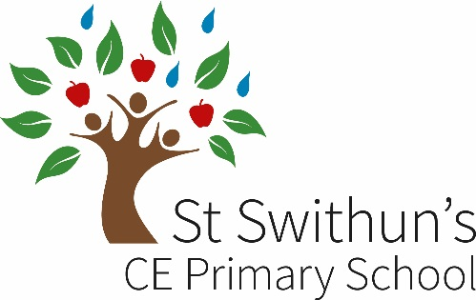

**JOB ADVERT**

**Key Stage 1**

**Post: KS1 teacher – full time 4 days (temporary maternity cover)**

**Pay Scale: MPS**

**Closing date: 5th November 2025**

**Interview date: 11th November 2025**

**Start date: January 2026**

We are looking to appoint a inspiring Key Stage 1 teacher. This is a great opportunity to work in a friendly and supportive school continuing to drive excellent outcomes for all our children.

St Swithun’s CE Primary school is a vibrant and happy two-form entry school, situated at the heart of Kennington village, mid-way between Oxford and Abingdon. Although we are large in number, we aim to meet the needs of the individual child and provide a stimulating place for children to learn. Our staff team are motivated and welcoming, and there is a great atmosphere in school with an emphasis on teamwork.

Are you someone who:

* Is motivated and enthusiastic about teaching.
* Can make learning exciting.
* Has high expectations of all children in both learning and behaviour.
* Is flexible in growing their practice.
* Works well as part of a dedicated and hardworking team.
* Is passionate about making learning a challenging and enjoyable experience.

We can offer you:

* Enthusiastic and friendly children.
* A positive, happy and supportive working environment.
* A fantastic school community working all working towards achieving the best for our children.
* Excellent CPD and support.

This is a temporary post covering maternity leave and there is flexibility on how many days worked.

Visits to the school are much encouraged and will provide a chance to meet some of our staff and children. To arrange a visit please contact the school office on [office.3258@st-swithuns.oxon.sch.uk](mailto:office.3258@st-swithuns.oxon.sch.uk) / 01865 415105.

**Application Procedure**

To apply visit our school website on [www.stswithunsprimary.org](http://www.stswithunsprimary.org) where you will find more information and an application form under the tab – About Us/Job Vacancies.

Please download the application form and email to – recruitment@st-swithuns.oxon.sch.uk.

Oxfordshire Schools are committed to safeguarding and promoting the welfare of children and young people and expect all staff and volunteers to share this commitment. This post involves the type of work with children and young people that requires applicants to undertake a Disclosure and Barring Service check. The possession of a criminal record will not necessarily prevent an applicant from obtaining this post. All users are considered confidentially and according to the nature of the role and information disclosed.