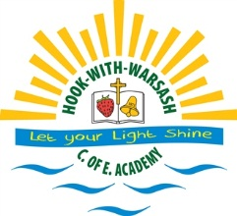

An Introduction to Hook with Warsash C of E Academy

Welcome to our academy from the Headteacher, Teaching Staff, Governors and PTFA. We are dedicated to maintaining the long tradition the school has in providing the highest possible standards not only in education, care, sport, music, and social skills but also helping to develop self-confidence and self-esteem to help our pupils prepare for now and the future.

Hook-with-Warsash Church of England (Controlled) Primary School was opened as an all-age school in 1871. In February 1980, Phase 1 of a programme to replace the old school was completed. Phase 2 was finished in July 1989 and the whole school now occupies a site a quarter of a mile away from the original school buildings. A further extension was built in 1994.

The school has been featured in the Sunday Times Guide to Education as one of the best schools in the country. The school is an academy which means it has the status of an independent school which is fully funded by the Department for Education.

There are fourteen classrooms, a music/drama room, and a large extremely well stocked library and a purpose built computer suite. There are separate playgrounds for infant and junior children, a large playing field and an extensive environmental work area with a large pond.

The school building is very well resourced. Each classroom has IT resources, science and maths equipment. There are an additional three laptop trolleys available for class use. Work is also displayed in every shared area, which communicates the current projects and shows the value placed on the children’s achievements.

