** Lunchtime Supervisory Assistant (LSA)**

**Applicant Pack**

Thank you for your interest in joining St Francis CE Primary School. We hope that this pack provides you with all the information you need, but please don’t hesitate to contact Eleanor Edwards, School Business Manager, via [adminoffice@st-francis-pri.hants.sch.uk](mailto:adminoffice@st-francis-pri.hants.sch.uk) with any questions you may have about the school or role. Visits to the school are warmly welcomed, please contact Eleanor via the office to arrange this.

**LSA- Key Recruitment Information**

* **Application Closing Date:** Ongoing
* **Interview Date(s):** variable- we reserve the right to interview on receipt of applications
* **Job Start Date:** ASAP
* **Contract/Hours:**  11.45-13.00 Monday-Friday. We are particularly looking for staff who could work a Monday and/or Wednesday but do have spaces on every day.
* **Salary:** Band A. £12.56 per hour (FTE £24,225).
* **Location of Role:** St Francis CE Primary School, Valley Park, Chandlers Ford
* **Contact e-mail address:** [adminoffice@st-francis-pri.hants.sch.uk](mailto:adminoffice@st-francis-pri.hants.sch.uk)

**Job/Person Summary**

We are looking to recruit somebody who enjoys working with children to join our team of lunchtime supervisors. You will need to be punctual, able to communicate with children and adults well and be able to show understanding of the importance of safety and safeguarding. We are looking for somebody who understands that all children are individuals and who listens to what they need.

This role is ideal for anyone looking to gain experience working in a school setting. Post holders often go on to secure Special Needs Assistant or Teaching Assistant roles, and we have a strong track record for promoting internally from our lunch team.

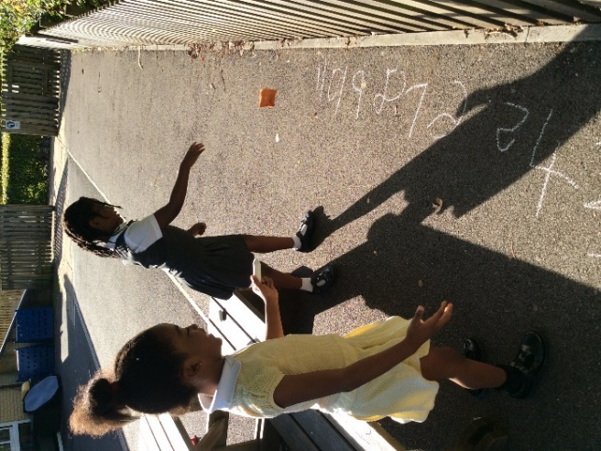**The role involves:**

* Helping to organise our pupils in the hall, classrooms and outside areas, encouraging positive behaviour and supporting healthy eating.
* Supervising and supporting play activities and encouraging children to participate in lunchtime activities.
* Promoting independence and positive play.
* Ensuring the safety and welfare of all our pupils.
* Dealing with minor first aid needs (training available)

**If you are:**

* Keen to work in a highly successful school and committed to be part of a very supportive staff team
* Friendly, flexible and eager to develop personally and professionally
* Dedicated, hardworking and enthusiastic, with a good understanding of your own work life balance

**Then we can offer:**

* Children who are motivated, keen to learn and proud of their school and achievements
* Supportive, friendly and committed colleagues who will welcome you to our team
* Commitment to your professional development and CPD opportunities within the school and local authority

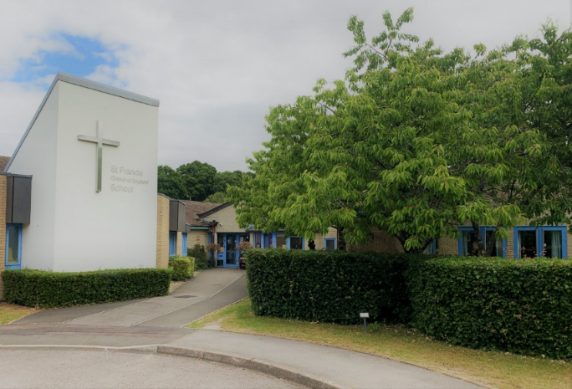**About St Francis CE Primary School**

Our vision is a community characterised by a deep passion and belief for everyone to thrive, rooted in our Christian ethos of belonging. Through sharing in God’s love, we enable all to grow, learn and flourish as individuals, becoming role models for our Christian values within our community and equipping us to follow and lead in the light of God through our journey within and beyond our school to enrich ours, and others’ lives.

**Our School Values**

Our whole school Christian values are important to us and weave throughout our daily lives, in play and learning: ***Together in God’s love we care, trust and respect.***

**Our School Charter**

1. Always try your best

2. Be caring, kind and helpful to others

3. Look after everything at school

4. Show good manners

5. Stay safe

6. Tell an adult if you’re unhappy

**St Francis CE Primary School Charter**

It is our aim that St Francis CE Primary School provides a warm, caring environment for all children to become successful learners. We therefore expect high standards of behaviour to be maintained by all. Underpinning this expectation is our School Charter setting out the rules, which direct the way everyone conducts themselves at St Francis School.

**How to Apply**

To apply for this role, please download an application form available from our website <https://www.stfrancisceprimarysch.co.uk/vacancies/> and return to the school office by emailing [adminoffice@st-francis-pri.hants.sch.uk](mailto:adminoffice@st-francis-pri.hants.sch.uk) before the application deadline or in hard copy. Please note that the school cannot accept applications submitted on other forms and applications made by CV will be rejected.   
 *St Francis CE Primary and Hampshire County Council are committed to safeguarding and promoting the welfare of children and young people and expect all staff and volunteers to share this commitment. We will ensure that all our recruitment and selection practices reflect this commitment. All successful candidates will be subject to DBS checks along with other relevant employment checks.*