

**St Michael’s Church of England (Controlled) Infant School**

*Learning Together with Love at the Centre*

**Assistant Headteacher**

**Information Pack**



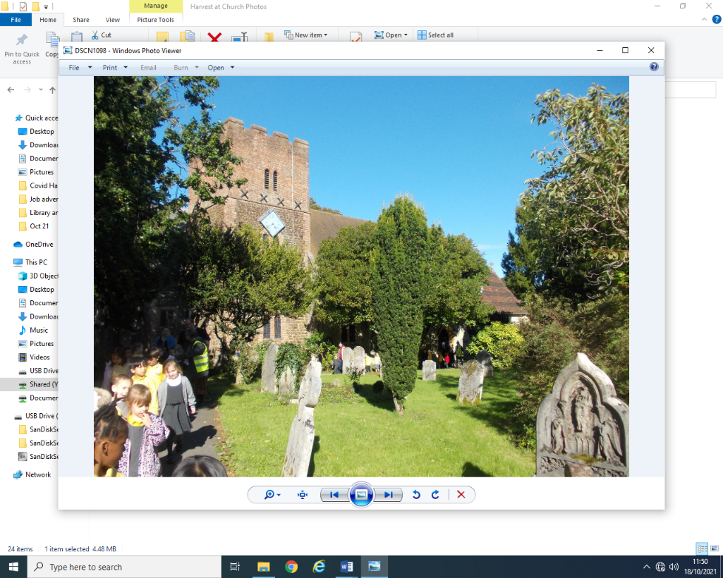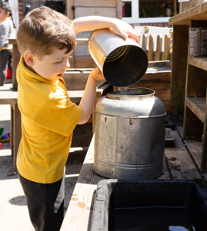

## St Michael's Infant School St Michael’s Church of England Infant School

## Park Road

## Aldershot

## Hampshire

## GU11 3PU

Headteacher: Mrs D Patton Telephone: 01252 324300

Dear Applicant,

Thank you for responding to our advert for the position of Assistant Headteacher (part time). I hope that you will find this pack useful. Please do not hesitate to contact the school to arrange a visit or to ask any questions about the post.

We are a three-form entry infant school in Aldershot. We are a wonderfully diverse community and our school values of love, forgiveness, friendship, truthfulness, perseverance and creativity are embedded in everything that we do.

I feel very lucky to be part of the team at St Michael’s Infant school, where we see everyone in the community as a life-long learner. I am extremely proud of the school and am committed to supporting all members of staff on their own learning journey and to achieve a work life balance.

The school recently had an Ofsted inspection, in March 2025 and was graded Good in all areas <https://files.ofsted.gov.uk/v1/file/50276238>

Some extracts from the report follow:

“The school is a warm and welcoming community. Pupils feel safe and happy because of the positive relationships they enjoy with adults and each other. If they have any worries, they know staff will help them. Pupils understand how the school’s values inspire them.”

“Pupils are enthusiastic about their learning and keen to share what they are doing. They enjoy working together and discussing their ideas. Pupils want to do well, and teachers help them when they need it. As a result, pupils’ achievement is improving, particularly in reading.

Pupils are respectful and kind. They celebrate difference and know the importance of learning about the views of others. Pupils respond well to high expectations for behaviour. They listen carefully in lessons. Pupils are proud to walk calmly around the school with their heads held high.”

“Staff enjoy working at the school. They value the efforts the school makes to manage their workload and support their well-being.”

We are now looking for an inspiring Assistant Headteacher to join our team and help to lead the school in the next stage of its journey. This is an exciting opportunity for an experienced teacher who has leadership skills and is interested in supporting teaching and learning and developing our curriculum further.

As soon as I walked into the school building and met the children myself, I knew that I wanted to be a part of this community and we hope that you get the same feeling when you visit us!

I would like to draw your attention to the following statement:

**St Michael’s Infant School is committed to safeguarding children and promoting the welfare of children and expects all staff and volunteers to share this commitment. We will ensure that all our recruitment and selection practices reflect this commitment. All successful candidates will be subject to Disclosure Barring Service (formerly CRB) checks along with other relevant employment checks.**

If you feel that St Michael’s Infant School could be a place where you would like to work, please complete the  application form together with the Equalities Monitoring Form and return it by email to d.patton@st-michaels-inf.hants.sch.uk by **midday on Monday 13th October.**

Interviews will take place in the week commencing **Monday 20th October** and we do try and contact everyone who has applied for the post before this date to inform you whether or not you will be invited for an interview.

We look forward to hearing from you soon,

Yours Sincerely,

Dot Patton

Mrs D Patton

Headteacher

**JOB DESCRIPTION**

**Job title**: Assistant Headteacher

**Responsible to:** The Headteacher

**Purpose of the job**

* Communicating the school’s vision compellingly and supporting the headteacher’s strategic leadership.
* Through setting high expectations, promote good progress and outcomes for pupils across the school.
* Developing the school curriculum
* Coaching and mentoring classroom staff so that teaching and learning continues to improve across the whole school
* Supporting the Headteacher with the day-to-day leadership and management of the school
* Leading and managing staff and supporting the Headteacher with staff appraisal

**School Culture and Behaviour**

* Help to continue to create a culture where our school values are upheld and children feel happy and safe to come to school
* Ensure a culture of staff professionalism and support the wellbeing of staff
* Use a relational approach to supporting pupils, staff and parents
* Have high expectations for the behaviour of pupils and ensure that they feel valued, respected and supported
* Have a clear understanding of the needs of all pupils, including those with special educational needs; those of high ability; those with English as an additional language; those with disabilities; and be able to use and evaluate distinctive teaching approaches to engage and support them

Strategic Leadership

* Support the Headteacher with school self-evaluation and development planning
* Work with leaders to use quantitative and qualitative measures to identify the strengths of the school and areas of improvement
* Help to formulate and implement plans for improvement and measure impact
* Uphold educational standards across the school so that children achieve the highest possible outcomes in their learning
* Establish and sustain professional working relationships with staff, holding them to account through constructive monitoring, mentoring and peer support

**Teaching, Curriculum and Assessment**

* Support, coach and mentor all teaching staff to ensure that there is consistency in high quality teaching and learning across the school
* Ensure the teaching of a broad, relevant, inspiring, structured and coherent curriculum
* Support subject leaders with the monitoring and development of their subject and ensure that all subjects areas meet the curriculum intentions
* Support teaching staff to be research driven with their subject pedagogy and professional practice
* Use data to analyse assessments and to review and evaluate pupil progress, rapidly identifying gaps in learning and supporting staff to adapt provision accordingly
* Track and analyse pupil performance data, paying particular attention to pupils who:
* Are eligible for the pupil premium
* Have SEN and/or disabilities
* Speak English as an additional language (EAL)
* Are LAC or PLAC
* Have had or have a social worker
* Plan and implement interventions for pupils who aren’t progressing
* Take responsibility for improving teaching across the school by providing appropriate professional development for all class based staff
* Support the Headteacher and middle leaders by organising and planning training and support for parents/carers
* Keep up to date with developments in education

**Special Educational Needs and Disabilities**

* Promote a culture and practices that allow all pupils to access the curriculum
* Have ambitious expectations for all pupils with SEND

**Governance, Accountability and Working in Partnership**

* Work with the governing board, presenting information and assisting governors with monitoring
* Support the Headteacher to make sure the school effectively and efficiently operates within the required regulatory frameworks and meets all statutory duties
* Work successfully with other schools and organisations
* Maintain working relationships with fellow professionals and colleagues to improve educational outcomes for all pupils
* Understand the breadth of diversity and needs within the community and communicate with professionalism, empathy and understanding

**Fulfil wider professional responsibilities**

* Follow the school Child Protection Policy and Safeguarding Policy to support the school in safeguarding all children .
* Participate in regular training about safeguarding and understand the importance of Keeping Children Safe in Education.
* Keep up to date in changes in KCSiE.
* Make a positive contribution to the wider life and ethos of the school.
* Develop effective professional relationships with colleagues, knowing how and when to draw on advice and specialist support.
* Deploy support staff effectively.
* Communicate effectively with parents with regard to pupils’ achievements and well-being.
* Help support all pupils to have an effective transition to their next class/school.
* To lead a subject and support other staff in this subject (not an ECT)

**Personal and professional conduct**

* Treat pupils with dignity, building relationships rooted in mutual respect and at all times observing proper boundaries appropriate to a teacher’s professional position.
* Have regard for the need to safeguard pupils’ well-being in accordance with statutory provisions.
* Show tolerance of and respect for the rights of others.
* Understand and apply the fundamental British values, including democracy, the rule of law, individual liberty and mutual respect, and tolerance of those with different faiths and beliefs.
* Have proper and professional regard for the ethos, policies and practices of the school, and maintain high standards in their own attendance and punctuality



**St Michael’s Church of England Infant School**

**Personal Specification**

|  |  |  |
| --- | --- | --- |
|  | **Essential** | **Desirable** |
| **Professional Qualification** | * Qualified teacher status e.g: PGCE, B.Ed. | * Professional development in preparation for leadership role |
| **Experience** | * Leadership and management experience in a school * Primary teaching experience * Experience of planning and developing a subject/subjects * Experience and knowledge of learning through play * Experience of leading and managing others * Experience of developing staff successfully * Experience of coaching and mentoring others * Good understanding of the needs of pupils with SEND | * EYFS and KS1 experience * Experience of working with children and families with EAL * Experience of a relational approach to understand and support regulation and behaviour * Involvement in school evaluation and development planning * Experience of leading staff professional development * Evidence of improving teaching standards and pupil outcomes beyond own classroom |
| **Skills** | * Ability to articulate and communicate a vision for education and what this will look like in EYFS and KS1 * Understanding of high-quality teaching, and the ability to model this for others and support others to improve * Able to inspire and motivate others * Effective communication and interpersonal skills with a range of stakeholders * Ability to build effective working relationships * Able to work with parents and carers with compassion, understanding and professionalism * Self aware and able to reflect on own skills and areas for development | * Ability to constructively lead and support challenging conversations * Experience of positively leading and managing others through change * Ability to coach others to problem solve and improve |
| **Professional Knowledge and Development** | * Has an excellent pedagogical knowledge and passion for developing a creative curriculum * **Knows how to use formatative and summatative assessment to improve outcomes for children** * Understands the importance of own professional development and takes responsibility for this * Is knowledgeable and up to date about current issues in education * **Is research driven and able to use to improve** | * **Has knowledge of how to effectively lead, manage and motivate others** * **Able to lead the implementation of professional development across a key stage/school** * **Knows and understands the strengths and barriers for children with EAL** |
| **Knowledge** | * Up to date knowledge of the National Curriculum and Foundation stage curriculum * Has a strong disciplinary and substantive subject knowledge, * Understands how children learn * Knows how to plan, adapt and scaffold learning to secure and embed knowledge over time * Good working knowledge of effective planning systems and how to adapt based on real time assessment * Is able to use IT to facilitate both teaching and learning | * Understands how to use school data management systems to interrogate pupil data and identify strengths and weaknesses * In-depth knowledge of primary Mathematics and how to effectively plan, teach and assess |
| **Personal Qualities** | * Makes positive relationships with others across the community * A commitment to upholding public trust in school leadership and maintaining high standards of ethics, behaviour and professional conduct * Understands for to prioritise and organise to maintain a healthy work-life balance * Able to communicate effectively. * Is a good listener * Is flexible, adaptable and resilient * Is approachable and caring * Is able to delegate and build on others strengths * Commitment to maintaining confidentiality at all times * Commitment to safeguarding * Is highly reflective * Is well organised * Ability to prioritise * Has a sense of humour! | **Experience of managing self and others within a part time framework ????** |

