Welcome...

Dear Candidate,

Thank you for your interest in the position of After School Club Assistant at Fair Oak Infant School. Further information about our school can be found on our school website. www.fairoakinfant.co.uk

Fair Oak Infant School is one of the largest infant schools in Hampshire, and indeed the country. It is a popular, innovative and successful school with four classes per year group.

Our aim is to help our pupils become:
· successful learners, who enjoy learning, make progress and achieve
· confident individuals, who are able to live safe, healthy and fulfilling lives
· global citizens, who make a positive contribution to society.

We are looking for a friendly and enthusiastic person to join our team to work with children in our newly formed after school club. Only children in Year One and Year Two attend our club, as our Year R children attend a different setting. You will be responsible for planning and delivering sporting activities for the children.

If you wish to discuss this role further, or come and look around school, please contact the School Office.

Fair Oak Infant School is committed to safeguarding and promoting the welfare of children and expects all staff to share this commitment. We ensure that all our recruitment and selection practices reflect this commitment. All successful candidates will be subject to Disclosure and Barring Service checks, along with other relevant employment checks.

I would ask when applying for this role you explain how you feel your skills and attributes are a good fit for the role. I look forward to receiving your application. The closing date for applications is noon on Friday 29th August 2025.

Yours sincerely
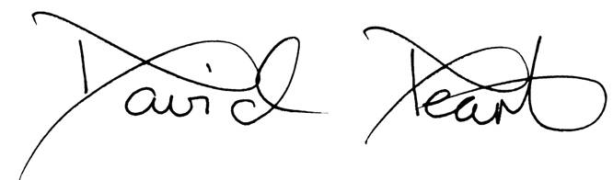

David Peart
Headteacher

After School Assistant

Salary – Grade C, £24,405 - £25,430 (pro rata £7,233 to £7,537 depending on experience)

12.5 hours, Monday to Friday – 3.00pm until 5.30pm
39 weeks a year – term time only
Permanent

We are looking for a fun, dynamic, enthusiastic and proactive person to work in our newly established after school club. Our club will provide after school care for children in Year One and Year Two. You will be responsible for delivering active and sporting activities for children, and other activities during colder / wetter months. Experience in delivering / coaching sport / sporting activities to young children would be an advantage, although not essential. You will be expected to plan a range of different activities and experiences for the children, in liaison with our After School Club Manager.

You will be responsible for a small group of children, rotating over the afternoon. Activities will be delivered outside, or in our school hall.

Responsibilities of the role will include:
- Supporting children with their snack
- Planning and delivery of a range of different sporting activities, suitable for young children
- Motivating and challenging children
- Providing first aid where required
- Ensuring children with additional needs are fully involved and able to access activities
- Ensuring children follow our three school expectations around their behaviour
- Setting up resources and putting them away at the end of the session
- Liaising with parents
If you would like to discuss the role further, please contact the Headteacher through the School Office.

Fair Oak Infant School and Hampshire County Council are committed to safeguarding and promoting the welfare of children and young people and expect all staff and volunteers to share this commitment. We will ensure that our recruitment and selection practices reflect this commitment. All successful candidates will be subject to Disclosure and Barring Service checks, along with other relevant employment checks.

Completed application forms should be emailed to Ian Peach, i.peach@fairoak-inf.hants.sch.uk
Closing Date: Friday 29th August 2025 (noon)
Start Date: September 2025

