Introduction

Appleton Church of England Primary school is situated in a beautiful village, 6 miles from Oxford.

After many years of stability, the school is now undergoing changes with several new members of staff and a relatively new governing board. The Headteacher has resigned following a period of illness and so an interim Headteacher is sought for a one-year initial period.

Our vision: At Appleton Church of England Primary School, we follow Jesus' example of love and learn to build wisely for life. The foundations of our caring and inclusive community are kindness, responsibility and respect, and we strive to be the best we can be for ourselves and for others.

Our key values: Kindness, Responsibility, Respect.

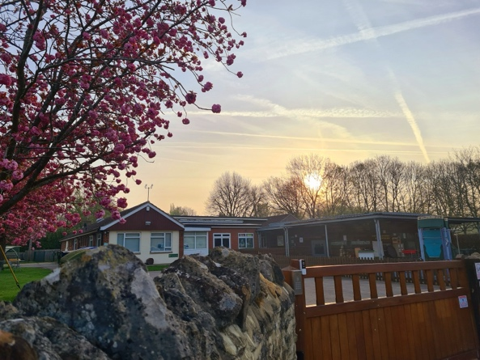
A whole-school curriculum is based around a variety of themes, making use of a range of teaching and learning styles and of the wealth of learning opportunities on our pupils’ doorsteps: in the immediate neighbourhood, through visits to the city’s museums and exhibitions, through work in the school’s grounds and through fieldtrips to other areas. Activities involving authors, artists, historians and scientists, as well as outdoor learning, all help to develop the children’s knowledge, understanding, skills and attitudes and their relationship with the local and wider world.
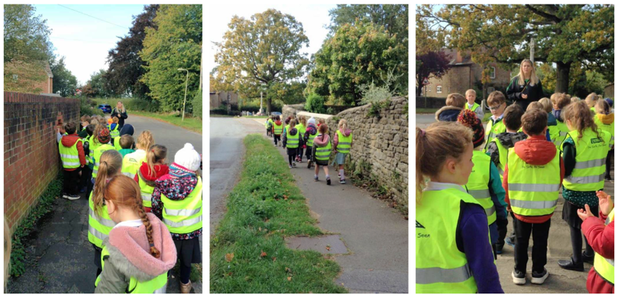
Parents and carers play an active role in the school, including through the Friends of Appleton (School Association) who organise fetes and other events in support of the school. The Governing Body consists of parent, church and local authority representatives. Governors support the school leadership in ensuring the provision of quality education: making sure that pupils are well equipped for the transition to secondary education, and for living as responsible and kind citizens in their communities.
The most recent Ofsted inspection of the school took place in 2022. This rated the school as ‘Good’. The latest SIAMS inspection took place in 2019 and the school was judged good overall and good for the impact of collective worship as well as for the effectiveness of RE.
School ethos
Appleton is a Church of England school with close contacts with the local St Laurence church. Pupils come from a variety of social, cultural and religious backgrounds. We welcome all: those from families who do not express adherence to a particular faith and those who come from a range of World Faith Backgrounds.
The school’s CofE foundation is important and pupils are involved in major Christian events which take place in the Church or at the school. The Rector, the Revd Wealands Bell, leads a weekly collective worship and is often in school.

The school prioritises the needs of its children: aiming to safeguard their welfare and inspiring them to become responsible, motivated life-long learners at the appropriate level of their abilities, including (but not limited to their academic achievements. In trying to offer a ‘home away from home’, staff of the school have a strong commitment to promoting and supporting the well-being of all pupils. The school operates wrap-around care, through a Breakfast Club and an After School Club.
Governors believe that links with the local community, including with those not directly involved with the school, are important: both as a resource to draw on in the school’s activities and as a means to showcase the work of the school. This is an area for further development.

Contexts
In the last year, the school has suffered from a falling roll (153) and this is a challenge in the wider context of a falling birth rate. In common with most schools, in the past ten or so years, funds delegated to the school by the government via the County have not grown sufficiently to make up for increasing costs. That trend too seems likely to continue for the foreseeable future. Both trends are having an effect on the operation of the school, and Governors are aware of strategic decisions that may have to be made in the future.
At present the classes are organised into single-year groups each with their own dedicated teacher(s). The school has a number of highly-valued support staff, but their roles and hours have to be reviewed annually.
Ensuring the provision of quality education and support to pupils, including through safeguarding policies and practices, whilst making effective and efficient use of available resources is the top priority of the school. Governors are currently reviewing how best to ensure this for the coming years. Information about the latest budget submission, and about proposals for staffing and classroom arrangements will be provided at interview.
Apart from external inspections by Ofsted and SIAMS, the school makes use of advisory visits from Headteacher colleagues in other schools, from the school’s link advisor of the Oxford Diocesan Board of Education (ODBE) and from Oxfordshire County Council officers. The leadership team is at present being supported by another local school. The school’s improvement plan is updated to take account of the outcomes of such visits, internal evaluations of curriculum organisation, and the results of teaching and learning.
The school buildings are in a good state of repair and the school is working closely with the Diocese to ensure that this continues.
Building on the school’s strengths and addressing its challenges
In developing the Headteacher’s person specification (see below), governors considered the strengths and weaknesses of the school.
BUILDING ON EXISTING SCHOOL STRENGTHS AND OPPORTUNITIES
- The existence of a well-motivated, skilled and experienced staff team, who exhibit a great team spirit. Staff value and respect each other and the children.
- Children are generally well-behaved. They are celebrated as individuals and supported according to their individual needs.
- The current leadership team have been working to provide personal and regular communications - both to individuals requiring support and the wider-school community - and this has been greatly valued by parents and carers.
- Developing links with the wider community form an important part of the school’s work.
Appleton School offers a Headteacher the opportunity to make a significant impact on the development of the school; on the learning of pupils, including, for example, by building on the mutually supportive and collaborative way of working amongst staff and by nurturing the school’s relationship with parents, carers and the local community. There is a huge amount of goodwill in the local community who share the school’s vision and values, and are deeply committed to supporting the school to thrive.
ADDRESSING CHALLENGES
- A falling roll means that there is a challenge to grow numbers in the school.
- Budgets require ongoing review to ensure that the quality of education and support for pupils remains good.
- Working closely with the Friends of Appleton and the wider community may support the school with funding.
- Changes in staffing in all roles means that developing a strong team is important.
Job description and salary
Applicants should refer to the duties and responsibilities of Headteachers described in the government’s latest ‘Guidance on Headteachers’ Standards’, available at the following link: https://www.gov.uk/government/publications/national-standards-of-excellence-for- headteachers/headteachers-standards-2020
The Headteacher will be the school’s ‘Designated Safeguarding Lead’.
The salary offered is in the range of Leadership Group 2 point 14-21
Applications
To apply for the post please use the application form attached and submit it together with any other relevant information to the Chair of Governors at aparham@appleton.oxon.sch.uk
In completing the application form, in addition to providing the requested information and explaining the extent to which you meet the Person Specification, please give particular attention to why you feel your experiences, skills and disposition would make you a suitable interim Headteacher for Appleton CofE Primary School.
- Closing date for applications: 12:00 midday, Friday 4th July.
- Results of the shortlisting process will be communicated by email to applicants by 19:00, Friday July 4th.
- Interviews of shortlisted candidates: Shortlisted applicants will be informed of the exact programme and timings by 19:00, Friday 4th July.
- Appleton CofE Primary School is committed to safeguarding children and young people. This post involves the type of work with children and young people that requires applicants to undertake a Disclosure and Barring Service check.

