

**St Michael’s Church of England (Controlled) Infant School**

*Learning Together with Love at the Centre*

**Class Teacher**

**Information Pack**

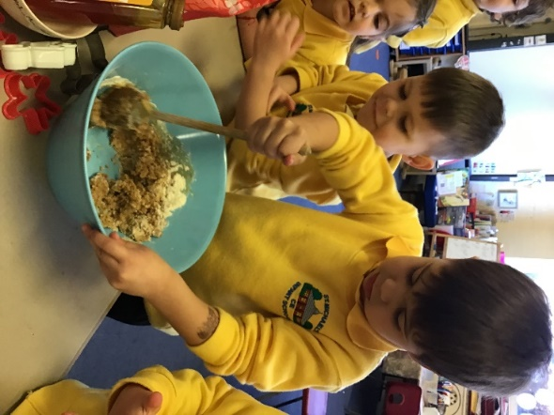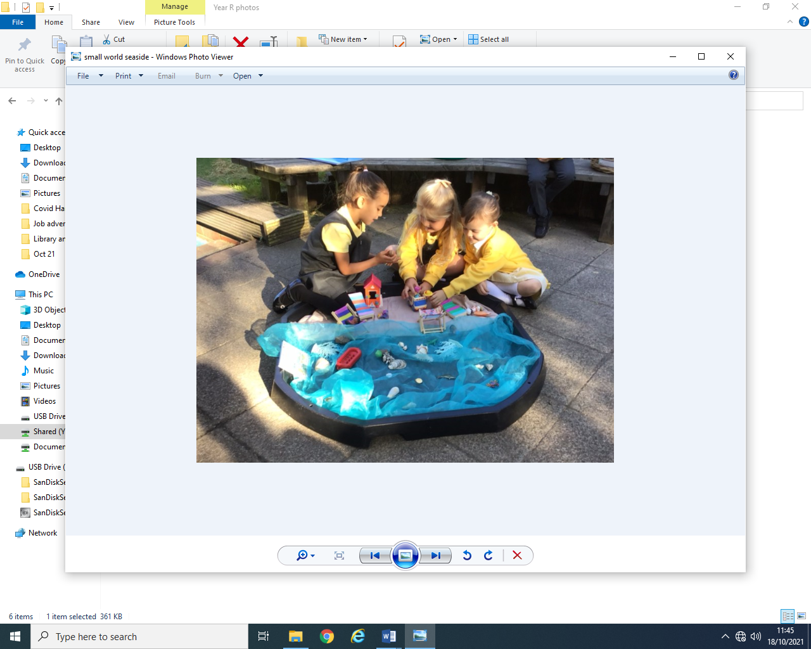

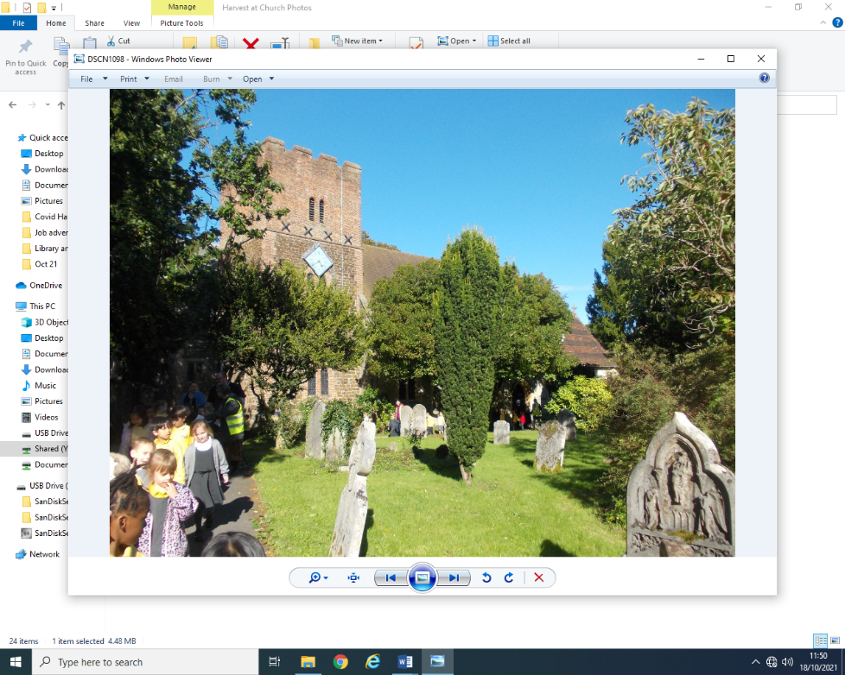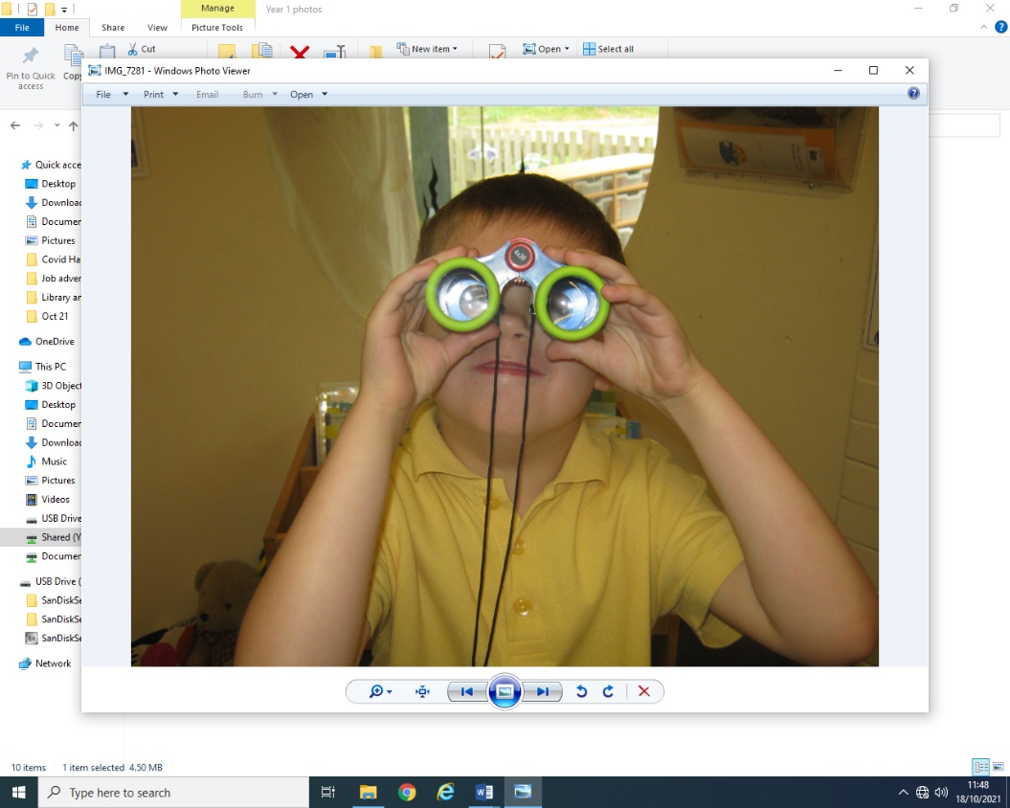

## St Michael's Infant School St Michael’s Church of England Infant School

## Park Road

## Aldershot

## Hampshire

## GU11 3PU

Headteacher: Mrs D Patton Telephone: 01252 324300

Dear Applicant,

Thank you for responding to our advert for the position of a class teacher. I hope that you will find this pack useful. Please do not hesitate to contact the school to arrange a visit or to ask any questions about the post.

We are a three form entry infant school in Aldershot. We are a wonderfully diverse community and our school values of love, forgiveness, friendship, truthfulness, perseverance and creativity are embedded in everything that we do.

I feel very lucky to be part of the team at St Michael’s Infant school, where we see everyone in the community as a life- long learner. I am extremely proud of the school and am committed to supporting all members of staff on their own learning journey and to achieve a work life balance.

The school recently had an Ofsted inspection, in March 2025 and was graded Good in all areas <https://files.ofsted.gov.uk/v1/file/50276238>

Some extracts from the report follow:

“The school is a warm and welcoming community. Pupils feel safe and happy because of the positive relationships they enjoy with adults and each other. If they have any worries, they know staff will help them. Pupils understand how the school’s values inspire them.”

“Pupils are enthusiastic about their learning and keen to share what they are doing. They enjoy working together and discussing their ideas. Pupils want to do well, and teachers help them when they need it. As a result, pupils’ achievement is improving, particularly in reading.

Pupils are respectful and kind. They celebrate difference and know the importance of learning about the views of others. Pupils respond well to high expectations for behaviour. They listen carefully in lessons. Pupils are proud to walk calmly around the school with their heads held high.”

“Staff enjoy working at the school. They value the efforts the school makes to manage their workload and support their well-being.”

We are looking for an inspiring, class teacher to join our team. This is an exciting opportunity for an experienced teacher, looking to develop their skills further in a highly nurturing and supportive school. As soon as I walked into the school building and met the children myself, I knew that I wanted to be a part of this community and we hope that you get the same feeling when you visit us!

I would like to draw your attention to the following statement:

**St Michael’s Infant School is committed to safeguarding children and promoting the welfare of children and expects all staff and volunteers to share this commitment. We will ensure that all our recruitment and selection practices reflect this commitment. All successful candidates will be subject to Disclosure Barring Service (formerly CRB) checks along with other relevant employment checks.**

If you feel that St Michael’s Infant School could be a place where you would like to work, please complete the [teaching application form](teaching-application-form-2021%20(8).docx) together with the [Equalities Monitoring Form](HampshireSchools-EqualitiesMonitoringForm%20(2).docx) and return it by email to d.patton@st-michaels-inf.hants.sch.uk by **midday on Thursday 12 June 2025.**

Interviews will take place in the week commencing **Monday 16 June** **2025** and we do try and contact everyone who has applied for the post before this date to inform you whether or not you will be invited for an interview.

We look forward to hearing from you soon,

Yours Sincerely,

Dot Patton

Mrs D Patton

Headteacher

**JOB DESCRIPTION – CLASS TEACHER**

**Job title**: Class Teacher

**Responsible to:** The Headteacher

**Purpose of the job**

* To have a commitment to the school vision and values and contribute to the team ethos of the school.
* Through setting high expectations, promote good progress and outcomes for pupils across the school.

**Set high expectations which inspire, motivate and challenge pupils**

* Establish a safe and stimulating environment for pupils, rooted in mutual respect.
* Set goals that stretch and challenge pupils of all backgrounds, abilities and dispositions.
* Demonstrate consistently the positive attitudes, values and behaviour which are expected of pupils.
* Where possible, try to involve pupils in leadership roles within the classroom.
* Try to ensure that pupils are aware of the high quality outcomes that they are required to produce and how to achieve these outcomes.
* Help to support pupils to learn from their mistakes and foster a culture where mistakes are not seen as failure.
* Ensure that the learning environment reflects the values of the school and is stimulating and well organised.
* Promote a love of books and reading.

**Promote good progress and outcomes by pupils**

* Be accountable for pupils’ attainment, progress and outcomes.
* Be aware of pupils’ capabilities and their prior knowledge, and plan teaching to build on these.
* Guide pupils to reflect on the progress they have made and their emerging needs.
* Demonstrate knowledge and understanding of how pupils learn and how this impacts on teaching.
* Encourage pupils to take a responsible and conscientious attitude to their own work and study.

**Demonstrate good subject and curriculum knowledge**

* Have a secure knowledge of the relevant subject(s) and curriculum areas, foster and maintain pupils’ interest in the subject, and address misunderstandings.
* Have a good understanding of teaching phonics.
* Demonstrate a critical understanding of developments in the subject and curriculum areas, and promote the value of scholarship.
* Demonstrate an understanding of and take responsibility for promoting high standards of literacy, articulacy and the correct use of standard English.

**Planning**

* Promote a love of learning and children’s intellectual curiosity.
* Help to contribute to the design and provision of an engaging curriculum.
* Where possible, link planning to the school values.
* Plan using AfL principles and practice.
* Set homework (as appropriate to the child’s age- usually reading, spelling and phonics) and plan other out-of-class activities to consolidate and extend the knowledge and understanding pupils have acquired.
* Reflect systematically on the effectiveness of lessons and approaches to teaching.

**Adapt teaching to respond to the strengths and needs of all pupils**

* Know when and how to adapt learning to the needs of all of the children.
* Have a secure understanding of how a range of factors can inhibit pupils’ ability to learn, and how best to overcome these.
* Demonstrate an awareness of the physical, social and intellectual development of children, and know how to adapt teaching to support pupils’ education at different stages of development.
* Have a clear understanding of the needs of all pupils, including those with special educational needs; those of high ability; those with English as an additional language; those with disabilities; and be able to use and evaluate distinctive teaching approaches to engage and support them.

**Make accurate and productive use of assessment**

* Know and understand how to assess the relevant subject and curriculum areas, including statutory assessment requirements.
* Make use of formative and summative assessment to secure pupils’ progress.
* Use relevant data to monitor progress, set targets, and plan subsequent lessons.
* Give pupils regular feedback, both orally and through accurate marking, and encourage pupils to respond to the feedback.

**Manage behaviour effectively to ensure a good and safe learning environment**

* Have clear rules and routines for behaviour in classrooms, and take responsibility for promoting good and courteous behaviour both in classrooms and around the school, in accordance with the school’s behaviour policy.
* Manage classes effectively, using approaches which are appropriate to pupils’ needs in order to involve and motivate them.
* Maintain good relationships with pupils, exercise appropriate authority, and act decisively when necessary.

**Fulfil wider professional responsibilities**

* Follow the school Child Protection Policy and [Safeguarding Policy](Safeguarding_Policy_2024-25_v2.pdf) to support the school in safeguarding all children .
* Participate in regular training about safeguarding and understand the importance of Keeping Children Safe in Education.
* Keep up to date in changes in KCSiE.
* Make a positive contribution to the wider life and ethos of the school.
* Develop effective professional relationships with colleagues, knowing how and when to draw on advice and specialist support.
* Deploy support staff effectively.
* Take responsibility for improving teaching through appropriate professional development, responding to advice and feedback from colleagues, attending meetings and courses that are part of professional development and CPD.
* Communicate effectively with parents with regard to pupils’ achievements and well-being.
* Help support all pupils to have an effective transition to their next class/school.
* To lead a subject and support other staff in this subject (not an ECT)

**Personal and professional conduct**

* Treat pupils with dignity, building relationships rooted in mutual respect and at all times observing proper boundaries appropriate to a teacher’s professional position.
* Have regard for the need to safeguard pupils’ well-being in accordance with statutory provisions.
* Show tolerance of and respect for the rights of others.
* Understand and apply the fundamental British values, including democracy, the rule of law, individual liberty and mutual respect, and tolerance of those with different faiths and beliefs.
* Have proper and professional regard for the ethos, policies and practices of the school, and maintain high standards in their own attendance and punctuality.
* Have an understanding of, and always act within, the statutory frameworks which set out the professional duties and responsibilities of a teacher.



**St Michael’s Church of England Infant School**

**Personal Specification**

|  |  |  |
| --- | --- | --- |
|  | **Essential** | **Desirable** |
| **Professional Qualification** | * Qualified teacher status e.g: PGCE, B.Ed. |  |
| **Experience** | * Teaching experience in KS1 (this can be part of teacher training) * Experience of working as part of a team. | * Experience of using ICT for record keeping and data. |
| **Skills** | * Able to demonstrate effective teaching through personal examples and performance. * Commitment to create a stimulating learning environment. * A strong team player. * Ability to manage other adults in the classroom. * An understanding of how to support the needs of all pupils. * Has high expectations of both work and behaviour. * Understanding of effective provision for SEND and the needs of all learners. | * Is willing to contribute to the wider school community e.g: school events. |
| **Professional Knowledge and Development** | * A commitment to develop as a teacher and member of the learning community. * Has a passion for developing a creative curriculum. | * Is able to articulate own vision for education and what this will look like in the classroom. * Understands the importance of own professional development and takes responsibility for this. |
| **Knowledge** | * Up to date knowledge of the National Curriculum. * Has a strong subject knowledge, particularly of Maths, Phonics and English. * Understands how children learn. * Good working knowledge of effective planning systems. * Is able to use IT to facilitate both teaching and learning. | * Is knowledgeable and up to date about current issues in education. |
| **Personal Qualities** | * Makes positive relationships with others. * Able to communicate effectively. * Is a good listener. * Is flexible and adaptable. * Is approachable and caring. * Is able to delegate. * Is highly reflective. * Is well organised. * Has a sense of humour! |  |

