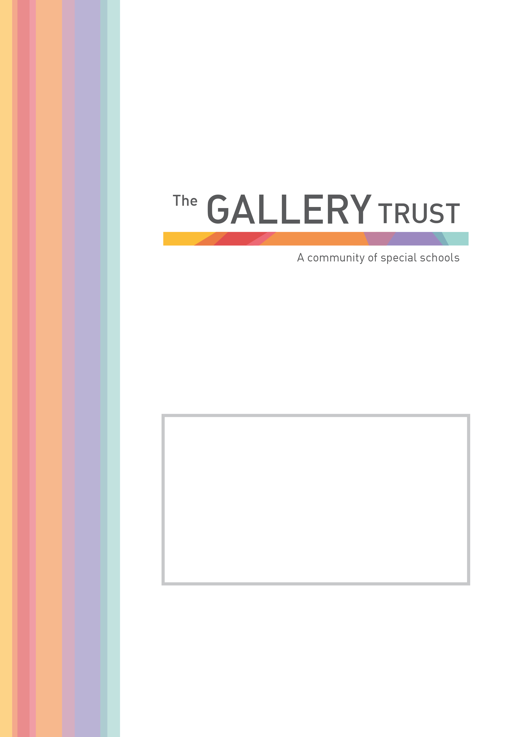
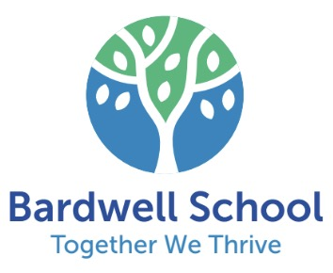
Administration Assistant
Bardwell School

Candidate Information Pack
September 2025


Thank you for your interest in the post of Adminstration Assistant at Bardwell School.

Bardwell School is a community special school for children aged 2 – 19 years with severe learning difficulties and profound and multiple learning difficulties. The school has 121 pupils on roll, following recent expansion of the school buildings.

We are passionate about students at Bardwell having their abilities recognised and celebrated, whilst receiving an excellent education. The staff team is committed to very high standards in relation to every aspect of our pupils’ education. The school is values led, with every decision underpinned by its principles and values. These values include a positive reinforcement approach to behaviour management and a non-label led, individualised approach to planning and delivering learning for all students.

Bardwell School is a member of The Gallery Trust, an expanding Special Needs Multi Academy Trust, which is dedicated to improving outcomes for SEND learners in Oxfordshire. The Trust has a national reputation for excellence and is influential in the development of SEND strategy in the county. With six academies currently in the Trust, our aim is to build a community of eight to ten special schools over the next five years.

Please visit our website to find out more about the school. If you would like to visit the school to find out more about this exceptional opportunity before you submit your application, you will be most welcome. Our staff and students will be delighted to meet you!

Thank you again for your interest and we look forward to hearing from you.



Jo McGill
Head Teacher

Teaching Assistant

Grade 6: £23,027 to £19,995.73
(FTE Salary £26,824 - £29,065 per annum)
Work Pattern: 37 hours per week, 39 weeks per year (term time, plus 5 days)

Monday to Thursday 08:00 - 16:00, Friday 8:00 - 15:30

We are seeking to recruit an enthusiastic and motivated Administration Assistant to join Bardwell School. The successful candidate will be a well-organised individual with good administration, clerical, and IT skills. You will have a supportive and positive approach with a ‘can-do’ attitude and will be able to prioritise a varied workload. Youwill enjoy working with our supportive and dedicated staff in our warm and caring community,alongside our fantastic students who have a range of Special Educational Needs and Disabilities. You will play an important role in greeting students, parents and visitors to the school and will undertake reception and attendance duties. Flexibility and versatility are corerequirements of this role, as no two days will be the same within our busy and friendly school office.
Benefits of working at Bardwell School include:
Professional development opportunities
- Regular training and access to a range of internal and external professional development opportunities, tailored to your learning needs, your job role and your career aspirations.
- Opportunities for career progression, secondments and transfers within The Gallery Trust, the largest special school Academy Trust in Oxfordshire.
- Opportunities for collaborative working across the schools in The Trust, offering the chance to liaise with experienced colleagues, building knowledge and professional networks
- Develop your career in The Gallery Trust, an expanding and successful organisation which offers opportunities for progression, secondments and collaborative working with colleagues across our schools
Financial
- Competitive salaries for teaching and support staff based on School Teacher Pay and Conditions Document and the NJC Green Book
- Access to attractive pension plans (TPS and LGPS), linked to salary life assurance
- Contribution towards glasses and eye tests for DSE use
- Salary sacrifice schemes, including childcare vouchers
- Perkbox - discount and wellbeing platform membership
Wellbeing
- 24/7 access to a free Employee Assistance Programme to provide confidential advice and guidance
- Membership to My Healthy Advantage wellbeing app
- Excellent induction processes, and strong line management structures to promote your wellbeing at work
- A culture which is open to employee ideas and encourages open dialogue

- Complimentary tea and coffee
- Regular staff surveys and gathering of staff views to gain feedback on wellbeing and to drive improvements
- The opportunity to join colleagues for social events
- Family friendly policies, which promote your wellbeing
- Cycle to work Scheme
- Weekly opportunity to purchase from the Post 16 lunch bar (currently soup and scone)
- Tuck shop – run by Post 16 provision (The Lodge)
Facilities
- Free car parking and cycle storage

Application Process

To apply for this post, please email jobs@bardwellschool.co.uk

Please submit your application form by the 16th October 2025 at 5:00pm to jobs@bardwellschool.co.uk or by post.

Please ensure you detail any gaps in employment and use the selection criteria which is contained in the job pack when you prepare your application, as shortlisting for interview will be based on how closely you demonstrate your ability to fulfil the essential criteria. We do not accept CVs. If you are shortlisted, we will take up written references before your interview so please provide permission for this and provide accurate phone and email contact details for your referees. One of your referees must be your current or last employer, and if you are employed in a school, must include your current Head Teacher.

The Gallery Trust is committed to safeguarding and promoting the welfare of all children and expects all staff to share this commitment. Any offer of employment with The Gallery Trust is subject to verification of ID and qualifications, satisfactory evidence of the right to work in the UK, health clearance, NCTL and Enhanced Disclosure and Barring Check. The Gallery Trust is an equal opportunities employer, and we welcome applications from candidates from all ethnic and community backgrounds.




The Gallery Trust is a Special Multi Academy Trust which is dedicated to improving outcomes for SEND learners in Oxfordshire. We strive to provide the best possible specialist learning experience for all pupils.

Our Strategic Aims

- Places where innovation drives learning – our schools have a clear purpose, they educate the whole child and prepare them for adulthood. Everything we do, from our curriculum offer to our pastoral care, is meaningful and driven by the needs of learners.

- Places where relationships drive engagement and achievement – our schools are built around exceptional relationships. We provide excellent experiences, growth, and opportunities for pupils and staff, and specialist working environments and resources.

- Places which provide exceptional knowledge and support – our schools are supported by a skilled and experienced central team which provides high quality school improvement and central support services.

- Places which inspire and influence – our schools are committed to collaborating with our local and national partners and communities to ensure that children and young people with SEND receive the education and opportunities they deserve.

As we enter the next phase of our development and build on our many successes, we want to embrace future challenges and opportunities. The Trust is on a continuing journey of expansion, growing from a Multi Academy Trust based on a single academy in 2013, to its position as the largest Special Trust in Oxfordshire. There are currently six special academies in the Trust located throughout Oxfordshire, with an additional academy opening in January 2024, and a further academy scheduled to open in 2026. The Trust’s vision is to continue to expand over the next five years, supporting a community of converter academies, free schools and sponsored academies, and providing outreach and other opportunities. All academies collaborate to share SEND expertise and best practice, and work in partnership with peers who are committed to common aims and goals.

The Board of Trustees believes that by providing the support of highly experienced and specialised school improvement and business teams, school leaders are empowered to focus on the standards of teaching and learning, and in meeting the operational and strategic demands of running their schools.

Bardwell School is a community special school that caters for children aged 2 – 19 years.

Students work in class groups where teachers differentiate learning for all students, ensuring lessons are inclusive for all.

The school has developed a comprehensive and broad skills-based curriculum, which can be found on the school’s website. This curriculum, which is underpinned by detailed assessment processes, guides the learning for all students. The school has excellent links with community partners and its strong focus on pathways to adulthood, supports students onto further education and into employment.

Bardwell School benefits from a hydrotherapy pool that has recently been refurbished. Pipil’s have termly blocks of weekly swimming lessons, and pupils with physically disabilities and/or physiotherapy programmes attend additional weekly sessions for movement swims as required.

The committed team at Bardwell School includes class teachers, teaching assistants, lunchtime supervisors, administrative staff, facilities manager and cleaning team, a pool manager and pool assistant, an ICT technician and Pastoral and Safeguarding manager.

The school is also commissioned to deliver a Short Break service, Branch-Out. This provision is highly regarded by parents and professionals and lead by the Short Breaks Lead and Short Breaks Deputy and has a team of play workers. Branch-Out provide after school clubs, youth clubs and holiday provision.

The school recognises its success is based on successful partnerships. Most importantly, the school works closely with parents and understands that families know their child best. The wider multi-professional team at Bardwell includes a Special School Nurse, Speech and Language Therapist, Occupational Therapist and Physiotherapist. The school also hosts health clinics through the special school nurse provision.

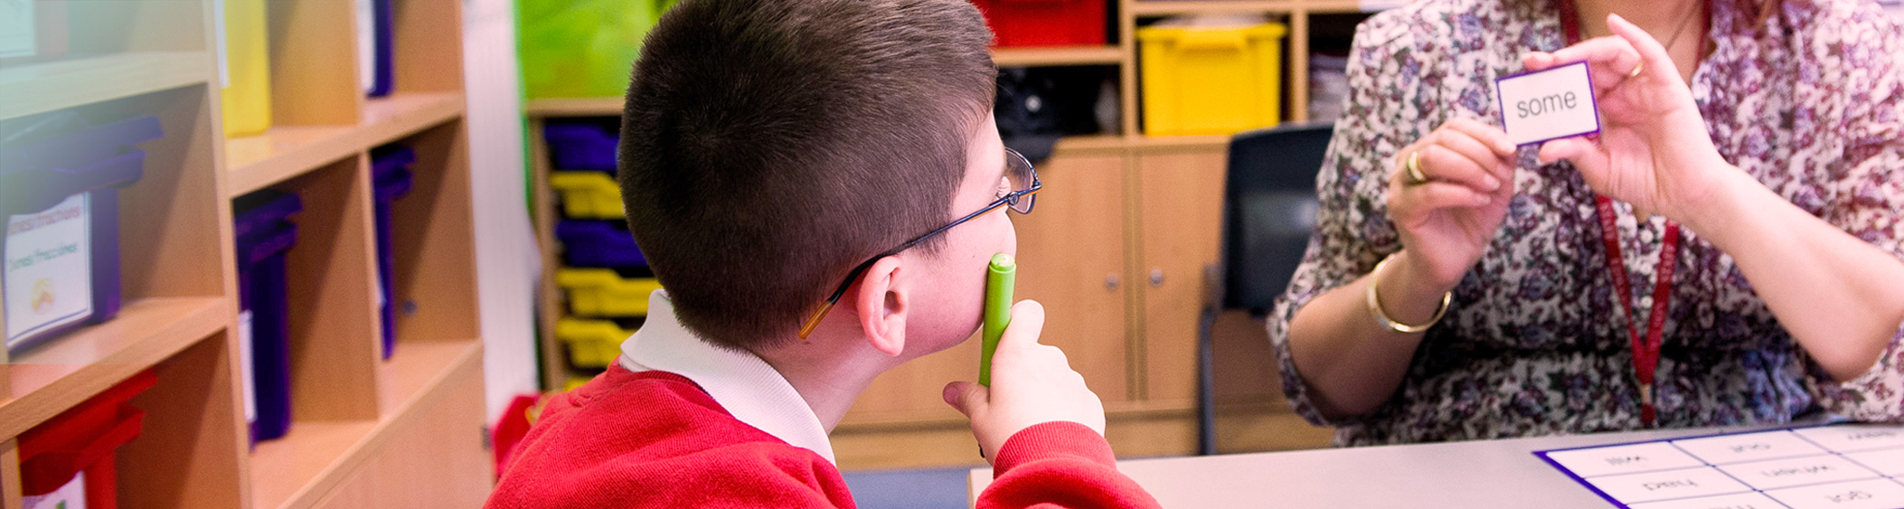

Administration Assistant

Job Description

Introduction:

This job description describes in general terms the normal duties which the post-holder will be expected to undertake. However, the job or duties described may vary or be amended from time to time without changing the level of responsibility associated with the post. The performance of all duties and responsibilities shown below will be under the reasonable direction of the Head Teacher. The Head will be mindful of her/his duty to ensure that the employee has a reasonable workload and sufficient support to carry out the duties of the post.

This job description will be reviewed at least annually and any changes will be subject to consultation. The school’s grievance procedure will be used to resolve any disagreement arising out of the job description.

Key Tasks

- Undertake reception duties, answering the telephone and face to face queries, and welcoming visitors in accordance with Safeguarding procedures
- Ensure registers are completed on time, twice daily
- Follow up on students absences and lateness and ensure all unexplained absences are accounted for
- Ensure lunch orders are entered correctly and provide summary to the kitchen in a timely manner
- Provide administrative and clerical support to colleagues
Undertake general administrative procedures and processes and clerical duties, e.g. photocopying, filing, answering emails, distribution of communications
- Undertake word processing and other IT based tasks, using a range of software
- Undertake arrangements e.g. in support of school trips and events etc
- Provide refreshments and housekeeping for meetings and visitors
- Assist in the arrangement of meetings, coordinating with attendees and providing relevant documentation, taking notes
- Take a role in the maintenance of record/information systems such as studentmrecords, and produce information as required e.g. attendance, student data
- Liaise with a range of internal and external stakeholders including students, staff, parents/carers, professionals, agencies, etc
- Maintain stocks and supplies

Standards and quality assurance:

- Support the aims and ethos of the academy
- Set a good example in terms of dress, punctuality and attendance
- Attend team and staff meetings
- Be proactive in matters relating to health and safety
- Participate positively in training and professional development
- Taking a share of supervisory duties as part of the weekly routine and as necessary
- Take part in Performance Management and appraisal
- Meet deadlines
- To follow school and county guidelines for safe working practice to safeguard pupils and staff in schools, maintaining confidentiality and attending training as required. Including:
- Reading and understanding Keeping Children Safe in Education (Part 1)
- Following our Code of Conduct (see staff handbook)
- Knowing and following our Child Protection/ Safeguarding Policy and
procedures
- Following procedures within our Whistleblowing Policy as appropriate.
- To be aware of and comply with Health and Safety legislation and policies of the school including;
- Cooperate with health and safety requirements.
- Report all defects on the maintenance forms and return them to the office.
- Complete and action risk assessments for all potentially hazardous on/off site activities.
- Use, but not misuse things provided for your health, safety and welfare.
- Assess the risk - do not undertake unsafe acts.
- Inform Head of Establishment of any “Near-Misses”.
- Be familiar with the emergency action plans for fire, first aid, bomb,
security and off site issues.
- Raise health, and safety and environmental issues with pupils.

General responsibilities:

- To promote the school and our pupils
- Any other class duties as directed by the School Business Manager, Head Teacher, Deputy Head Teacher or Assistant Headteachers.

Selection Criteria
Administration Assistant, Bardwell School
 | Essential | Desirable
Experience | - Good numeracy/literacy skills,  equivalent to GCSE Grade  4 or above (Grade C on old scaling)  - Knowledge of software packages and  applications including Microsoft Word,  - Excel, internet, email  Willingness to undertake training in  other software packages | ● First aid trained  ● Fire Marshall trained
Professional Knowledge & Skills | ● Experience of an administration or customer service role in a busy environment  ● Prioritising workload  ● Working in a team and on own initiative | ● Previous experience of working in a school or office environment  ● Providing administrative and organisational support to colleagues  ● Working with students with SEND
Personal Skills and Qualities | Friendly, flexible and welcoming approach  ● Good keyboard skills  ● Methodical and accurate approach to work  ● Able to communicate effectively,verbally and in writing, to a range of audiences, e.g. staff, students, visitors, parents  ● Willingness to undertake First Aid training and to support the medical and first aid needs of students.  ● Willingness to undertake Fire Marshall training  ● Able to cope with interruptions and remain calm under pressure  ● Able to work to tight deadlines and prioritise tasks, using own initiative while following directions  ● Willingness to take on new tasks as the role evolves  ● Able to promote a positive working environment, and work collaboratively with colleagues  ● A confidential and discreet approach
Other | ● Motivation to work with students with special educational needs in a school setting  ● Willingness to undertake CPD and training  ● Commitment to safeguarding, and the welfare of children and young people  ● A respectful approach to children and young people with SEN  ● High standards of professional conduct

