

**St Michael’s Church of England (Controlled) Infant School**

*Learning Together with Love at the Centre*

**SENDCO**

**Information Pack**



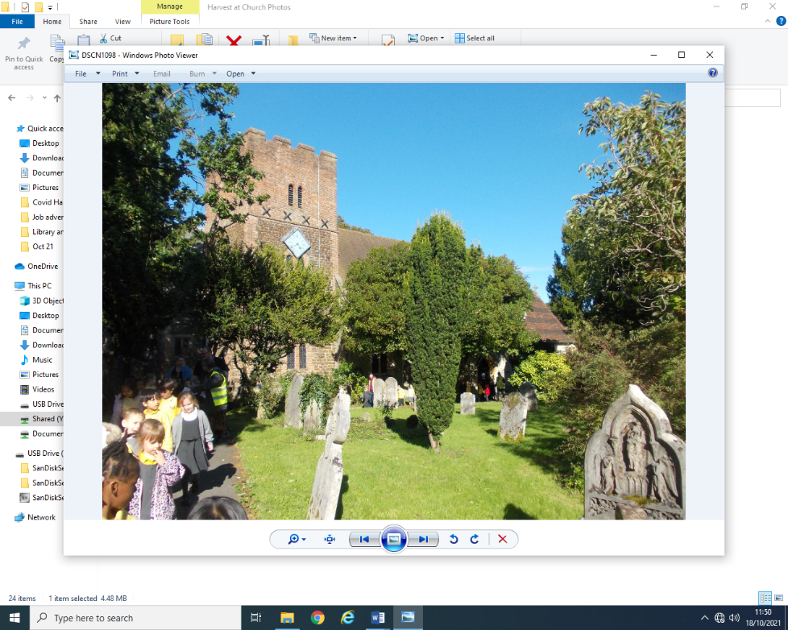

## St Michael's Infant School St Michael’s Church of England Infant School

## Park Road

## Aldershot

## Hampshire

## GU11 3PU

Headteacher: Mrs D Patton Telephone: 01252 324300

Dear Applicant,

Thank you for responding to our advert for the position of a SENDCO (part time). I hope that you will find this pack useful. Please do not hesitate to contact the school to arrange a visit or to ask any questions about the post.

We are a three- form entry infant school in Aldershot. We are a wonderfully diverse community and our school values of love, forgiveness, friendship, truthfulness, perseverance and creativity are embedded in everything that we do.

I feel very lucky to be part of the team at St Michael’s Infant school, where we see everyone in the community as a life- long learner. I am extremely proud of the school and am committed to supporting all members of staff on their own learning journey and to achieve a work life balance.

The school recently had an Ofsted inspection, in March 2025 and was graded Good in all areas <https://files.ofsted.gov.uk/v1/file/50276238>

Some extracts from the report follow:

“The school is a warm and welcoming community. Pupils feel safe and happy because of the positive relationships they enjoy with adults and each other. If they have any worries, they know staff will help them. Pupils understand how the school’s values inspire them.”

“Pupils are enthusiastic about their learning and keen to share what they are doing. They enjoy working together and discussing their ideas. Pupils want to do well, and teachers help them when they need it. As a result, pupils’ achievement is improving, particularly in reading.

Pupils are respectful and kind. They celebrate difference and know the importance of learning about the views of others. Pupils respond well to high expectations for behaviour. They listen carefully in lessons. Pupils are proud to walk calmly around the school with their heads held high.”

“Staff enjoy working at the school. They value the efforts the school makes to manage their workload and support their well-being.”

We are looking for an inspiring, enthusiastic and experienced SENDco. This is an exciting opportunity to join our senior leadership team. We pride ourselves on being an extremely nurturing and supportive school. As soon as I walked into the school building and met the children myself, I knew that I wanted to be a part of this community and we hope that you get the same feeling when you visit us!

I would like to draw your attention to the following statement:

**St Michael’s Infant School is committed to safeguarding children and promoting the welfare of children and expects all staff and volunteers to share this commitment. We will ensure that all our recruitment and selection practices reflect this commitment. All successful candidates will be subject to Disclosure Barring Service (formerly CRB) checks along with other relevant employment checks.**

If you feel that St Michael’s Infant School could be a place where you would like to work, please complete the  application form together with the Equalities Monitoring Form and return it by email to d.patton@st-michaels-inf.hants.sch.uk by **midday on Friday 7 November.**

Interviews will be arranged shortly after. We do try and contact everyone who has applied for the post before this date to inform you whether or not you will be invited for an interview.

We look forward to hearing from you soon,

Yours sincerely,

Dot Patton

Mrs D Patton

Headteacher

**JOB DESCRIPTION – SENDCO**

**Job title**: SENDCO

**Responsible to:** The Headteacher

**Purpose of the job**

* Determine the strategic development of the special educational needs (SEND) policy and provision in the school.
* Be responsible for day-to-day operation of the SEND policy and co-ordination of specific provision to support individual pupils with SEN or a disability.
* Provide professional guidance to colleagues, working closely with staff, parents and other agencies.
* To have a commitment to the school vision and values and contribute to the team ethos of the school.
* Through setting high expectations, promote good progress for pupils with SEND across the school.
* The SENDCO will be expected to fulfil the responsibilities of a teacher, as set out in the STPCD.

# **Duties and responsibilities**

Strategic development of SEND policy and provision

* Have a strategic overview of provision for pupils with SEN or a disability across the school, monitoring and reviewing the quality of provision.
* Contribute to school self-evaluation, particularly with respect to provision for pupils with SEN or a disability.
* Make sure the SEND policy is put into practice and its objectives are reflected in the school improvement plan (SIP).
* Maintain up-to-date knowledge of national and local initiatives that may affect the school’s policy and practice.
* Evaluate whether funding is being used effectively, and suggest changes to make use of funding more effective.

Operation of the SEND policy and co-ordination of provision

* Maintain an accurate SEND register and provision map.
* Provide guidance to colleagues on teaching pupils with SEN or a disability, and advise on the graduated approach to SEND support.
* Advise on the use of the school’s budget and other resources to meet pupils’ needs effectively, including staff deployment.
* Be aware of the provision in the local offer.
* Work with early years providers, other schools, educational psychologists, health and social care professionals, and other external agencies.
* Be a key point of contact for external agencies, especially the local authority (LA).
* Analyse assessment data for pupils with SEN or a disability.
* Implement and lead intervention groups for pupils with SEND, and evaluate their effectiveness.
* Become familiar with Provision Map software and use it as a tool for tracking children’s progress and monitoring interventions

Support for pupils with SEN or a disability

* Identify a pupil’s SEN
* Co-ordinate provision that meets the pupil’s needs, and monitor its effectiveness
* Secure relevant services for the pupil
* Ensure records are maintained and kept up to date
* Write and review education, health and care plans (EHCPs) with parents or carers, other professionals and the pupil
* Communicate regularly with parents or carers
* Ensure if the pupil transfers to another school, all relevant information is conveyed to it, and support a smooth transition for the pupil
* Promote the pupil’s inclusion in the school community and access to the curriculum, facilities and extra-curricular activities
* Work with the designated teacher for looked-after children, where a looked-after pupil has SEN or a disability

Leadership and management

* Work with the headteacher and governors to ensure the school meets its responsibilities. under the Equality Act 2010 in terms of reasonable adjustments and access arrangements.
* Prepare and review information the governing board is required to publish.
* Contribute to the school improvement plan and whole-school policy.
* Identify training needs for staff and how to meet these needs.
* Lead INSET and training for staff.
* Share procedural information, such as the school’s SEND policy.
* Promote an ethos and culture that supports the school’s SEND policy and promotes good. outcomes for pupils with SEN or a disability.
* Lead and manage teaching assistants (TAs) working with pupils with SEN or a disability.
* Lead staff appraisals and produce appraisal reports.
* Review staff performance on an ongoing basis.
* Support staff to implement the school behavior policy with children with SEND.
* Lead and manage the Ready to Learn provision with the year leader and class teachers.

**Fulfil wider professional responsibilities**

* Follow the school [Child Protection](https://files.schudio.com/st-michaels-infant-school/files/policies/Child_Protection_Policy_2025_2026.pdf) and [Safeguarding](https://files.schudio.com/st-michaels-infant-school/files/policies/Safeguarding_policy_2025_2026.pdf) policies to support the school in safeguarding all children.
* Participate in regular training about safeguarding and understand the importance of Keeping Children Safe in Education.
* Keep up to date in changes in KCSiE.
* Make a positive contribution to the wider life and ethos of the school.
* Develop effective professional relationships with colleagues, knowing how and when to draw on advice and specialist support.

**Personal and professional conduct**

* Treat pupils with dignity, building relationships rooted in mutual respect and at all times observing proper boundaries appropriate to a teacher’s professional position.
* Have regard for the need to safeguard pupils’ well-being in accordance with statutory provisions.
* Show tolerance of and respect for the rights of others.
* Understand and apply the fundamental British values, including democracy, the rule of law, individual liberty and mutual respect, and tolerance of those with different faiths and beliefs.
* Have proper and professional regard for the ethos, policies and practices of the school, and maintain high standards in their own attendance and punctuality.
* Have an understanding of, and always act within, the statutory frameworks which set out the professional duties and responsibilities of a teacher.



**St Michael’s Church of England Infant School**

**Personal Specification**

|  |  |  |
| --- | --- | --- |
|  | **Essential** | **Desirable** |
| **Professional Qualification** | * Qualified teacher status e.g: PGCE, B.Ed. * National award for SENDCO |  |
| **Experience** | * Teaching experience in EYFS or KS1 * Experience of working and leading as part of a team. |  |
| **Skills** | * Sound knowledge of the SEND Code of Practice * Understanding of what makes ‘quality first’ teaching, and of effective intervention strategies * Ability to plan and evaluate interventions * Data analysis skills and the ability to use data to inform provision planning * Effective communication and interpersonal skills * Ability to build effective working relationships * Ability to inspire others and negotiate * Good record-keeping skills |  |
| **Professional Knowledge and Development** | * A commitment to develop as a member of the learning community * Has a passion for learning * Can articulate own vision for inclusion | . |
| **Knowledge** | * Up to date knowledge of the National Curriculum * Has a strong subject knowledge, particularly of Maths, Phonics and English * Understands how children learn | * Is knowledgeable and up to date about current issues in education |
| **Personal Qualities** | * Makes positive relationships with others * Commitment to getting the best outcomes for pupils and promoting the ethos and values of the school * Commitment to equal opportunities and securing good outcomes for pupils with SEN or a disability * Ability to work under pressure and prioritise effectively * Commitment to maintaining confidentiality at all times * Commitment to safeguarding and equality * Is able to communicate effectively * Is a good listener * Is flexible and adaptable * Is approachable and caring * Is able to delegate * Is highly reflective * Is well organised * Has a sense of humour! |  |

