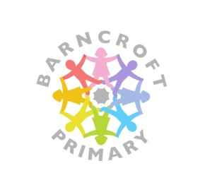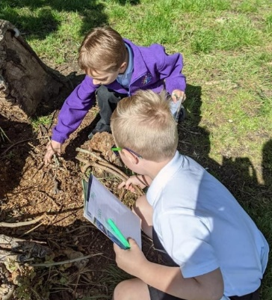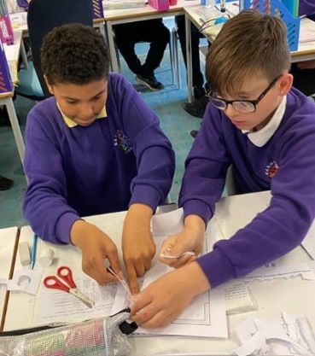

***Where learning comes to life!***

Our aim is to be an inclusive school in which all children enjoy outstanding learning experiences, make good progress and leave as responsible citizens.

At Barncroft, teaching and learning is good. Reading is given high priority. The curriculum is carefully planned to ensure progression in skills and knowledge.

Progress and attainment are tracked closely to identify any pupils falling behind.

Well-being and supporting children’s mental health is a priority for the school with regular check-ins for all pupils. Pupils’ spiritual, moral, social and cultural development is prioritised. Pupils’ attitudes to their learning are positive.

Our school was re-built in 2012 so we have lots of space and modern facilities. We have extensive school grounds and an indoor swimming pool.

We will offer you:

* A supportive SLT who are always there to listen and help
* Opportunities to make a significant impact on school improvement.
* Excellent professional development and future leadership opportunities
* Half-termly planning days off-site with your year team
* Time out of class for any extra responsibilities

