# Federation of Netley Abbey Infant and Junior Schools

# Learning Support Assistant Level 2

# Person Specification:

The Person Specification is an important part of the application process and will be used to shortlist candidates. You will need to demonstrate in your supporting statement/application form how you meet the following criteria.

|  |  |  |  |
| --- | --- | --- | --- |
|  | Essential | Desirable | |
| Qualifications & training | The LSA will have:  · O Level / GCSE Maths and English Grade C or above. | · Trained to NVQ 2 standard or equivalent knowledge,  · experience or skills. | |
| Experience | The LSA should have experience of:  · successfully supporting individuals or groups of pupils during independent/group work  · working successfully and co-operating as a member of a team |  | |
| A commitment to education and teaching | The LSA will have the ability to communicate and co-operate by:  · establishing and maintaining good professional relationships with pupils, parents and colleagues  · setting high expectations of all pupils and be committed to raising educational achievement  · adopting a flexible approach |  | |
| Knowledge and understanding | The LSA will have knowledge and understanding of:  · educational and curriculum matters  · behaviour and ethos  · communications  · equal opportunities  · have an understanding of special educational needs as defined in the SEN Code of Practice | · In addition, the LSA might also have knowledge and understanding of:  · using ICT as a learning tool  · be aware of practise relating to the Child Protection Policy  · record keeping evidence of assisting in the day-to-day management of the learning environment, e.g. marking/offering feedback, preparing learning resources | |
| Skills | The LSA will be able to:  · keep pupils on task, interested, motivated and engaged in their learning tasks  · evidence of providing feedback to the teacher about the learning activities, responses to the children and the support that has been provided  · ability to assist in the management of pupil behaviour.  · interpersonal skills  · Patience and empathy with pupils and sympathetic to their needs  · be able to work effectively in a team  · be able to relate well to both children and adults  · professionally discrete and able to respect confidentiality on particular issues  · ability to clarify and explain instructions clearly | In addition, the LSA might also be able to:  · Input to the professional development of other staff members  · Produce detailed, written reports on pupil progress and summaries of need. |
| Personal  characteristics | The LSA should be:  · knowledgeable and highly competent  · Good organisational ability  · approachable and empathetic  · creative and enthusiastic  · organised and resourceful  · intelligent and reflective  · committed  · flexible and adaptable  · evidence of fostering independence and self-esteem  · Take responsibility for own professional development, including setting and working towards annual performance objectives | In addition, the LSA might also have:  · a sense of humour |
| Special  requirements | The LSA should:  · have or be willing to undergo an Enhanced DBS check |  |

**The Children’s View**

Our children have reflected and thought about the type of qualities they would like to see in a new Learning Support Assistant.

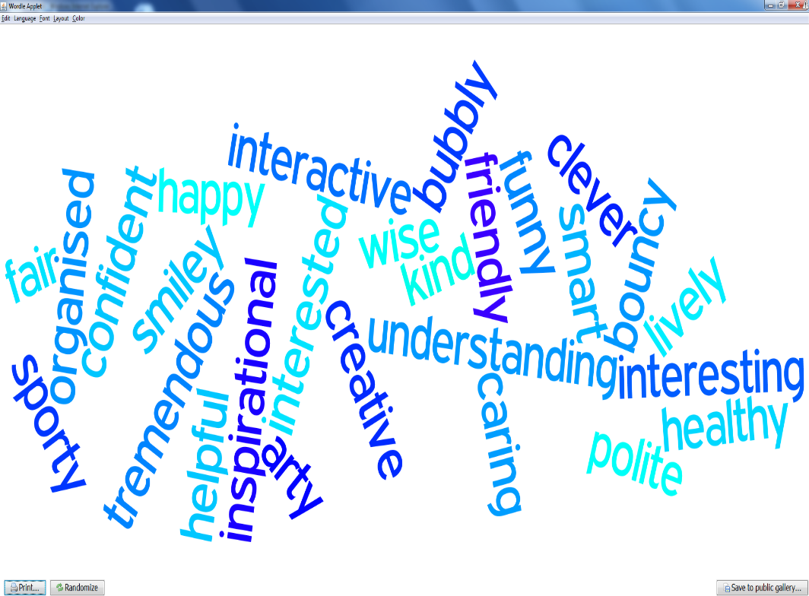

Are you…