 | SHARPS COPSE PRIMARY  SCHOOL

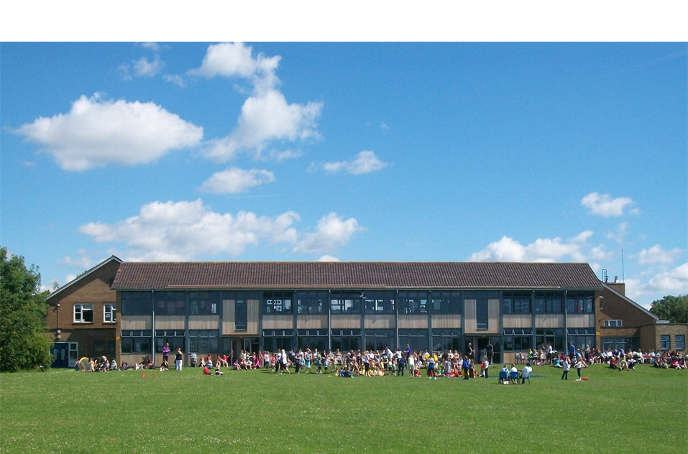

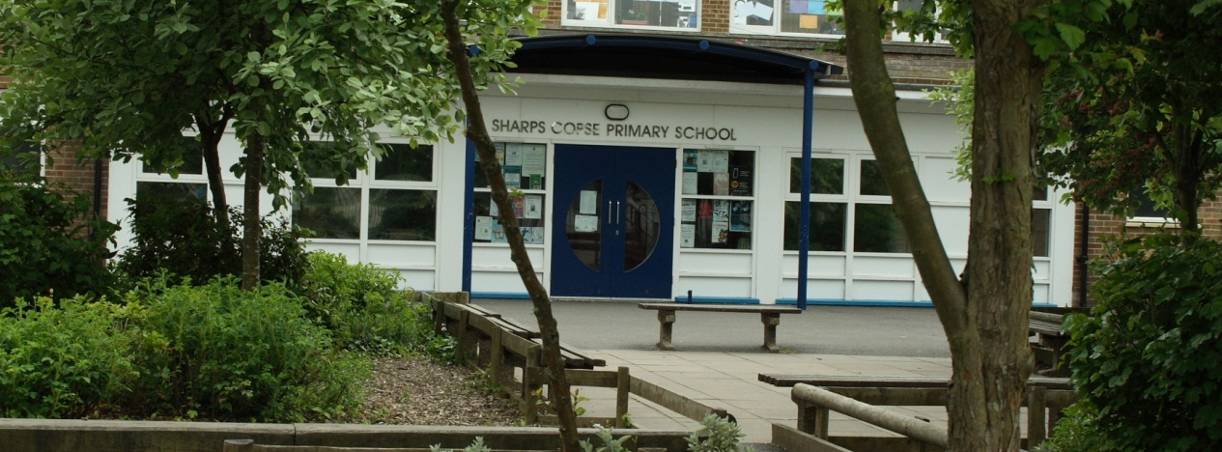
Special Needs Assistant (SNA)
Learning Support Assistant (LSA)
Teaching Assistant (TA)
Higher Level Teaching Assistant (HLTA)
Information Pack
Required for September 2026

HCC Support Staff Grade B, C or D
FTE Salary £24,796 - £30,564
(dependent on experience and qualifications)
Fixed Term Contract until August 2027
Monday – Friday, Term time only
8.30am – 3.15pm

Sharps Copse Primary School
Prospect Lane
HAVANT
Hampshire
PO9 5PE
Tel: 023 9248 4545

Office email: adminoffice@sharpscopse.hants.sch.uk
SHARPS COPSE PRIMARY
SCHOOL

 |  | Prospect Lane, HAVANT, Hants, PO9 5PE
Headteacher: | Mr M. Elsen - BEd (Hons) NPQH |  | Telephone: | 023 9248 4545
 |  | e-mail:  website: | adminoffice@sharpscopse.hants.sch.uk  www.sharpscopseprimary.co.uk

Our ref: SCPN SNA/LSA/TA/HLTA Recruitment – May 2026 May 2026

Dear Applicant,

Welcome and thank you for showing interest in the Special Needs Assistant/LSA, Teaching Assistant/Higher Level Teaching Assistant vacancies at our school; I hope that you find the information provided in this pack helpful. Visits to the school are strongly encouraged and warmly welcomed, to provide you with an opportunity to see our school in action. We are very proud of the development and growth of the school so far and plan to both sustain current achievement and move the school even further forward. We need an individual who will really believe in our school and will work with all of the teams within the school to secure even greater school improvement.

Exciting opportunities have arisen and our Headteacher and Governors are looking to recruit enthusiastic, self-motivated and dedicated assistants to support children with their education and individual needs in our school. We are looking for people with positive, caring and committed approaches to children. The role could be focused around 1:1 support in the first instance but with the support of the team around you, or working with our fantastic team of teachers in class, organising relevant resources, and if appropriate to your experience & qualification, you may be asked to provide classroom cover for teachers’ PPA and/or Leadership time.

At Sharps Copse we strive to provide our children with the very best education and you will be joining our friendly team of highly motivated and dedicated staff where excellent numeracy, literacy and initiative skills are essential as well as a commitment to making learning both meaningful and fun.

If you are passionate about making learning irresistible and enabling children to achieve their very best within a supportive team, then this position could suit you.

We look forward to receiving your application; in the meantime, if you wish to visit the school, please contact myself or Julie Jolliffe, our Business Manager on the above telephone number to make an appointment.

Yours sincerely

Mike Elsen

Mike Elsen
Headteacher

 |  |  |  | 

Key Features of Sharps Copse Primary
School

School Details

The school occupies an extensive and attractive open site within the borough of Havant and serves part of the Leigh Park estate, a large residential development, and mainly supports children from its immediate locality.

The Havant Academy is the main designated school at the point of transfer to secondary education, with whom Sharps Copse Primary School have established close links, thus ensuring ease of transition and curriculum continuity

The site was originally occupied by two schools built in the mid-1960s, Sharps Copse Infant and Nursery School and Sharps Copse Junior School, to accommodate 90 children in each year group. Since then the population has rapidly declined in Leigh Park and in 2002 the two schools amalgamated to create the new Sharps Copse Primary School now occupying the ex-junior school building; more recently undergoing a welcome refurbishment.

Sharps Copse Primary School has provision for the admission of 45 children organised into two reception classes; three mixed Year 1/2 classes, three mixed Year 3/4 classes and three mixed Year 5/6 classes.

Context

We are very proud of how Sharps Copse Primary School supports our children. Our nurturing and challenging culture and our extensive provision of extended services and activities are instrumental in providing our children with a firm basis for their future learning.

There are currently 281 children on roll, who come from varied socio-economic backgrounds. We have a much higher than average proportion of children eligible for free school meals. The number of children with special educational needs and/or disabilities is also above average. However, all staff encourage positive attitudes to learning, raising children’s aspirations and achievements.

Please visit the School’s website at www.sharpscopseprimary.co.uk for more information about our school.

Our School Vision and Values

Our Children will:

- Try new things with confidence and not be afraid to make mistakes
- Be independent learners and thinkers
- Know that they have achieved and what they need to do next
- Integrate well socially with peers and adults alike
- Be happy, secure and confident in their own abilities
- Be academically sound
- Learn to moderate their own behaviour and make the right choices regarding their own behaviour
- Enjoy school and find interest in their lessons and activities
- Show understanding, respect and knowledge that we live in a complex society

Our Values are:

S = standards

H = honesty

A = attitude

R = resilience

P = pride



Application Procedure for all roles

Candidates should complete the application form in full giving all relevant details of past experience, qualifications, reason for applying and contact details for references and return by no later than than 5pm on Wednesday, 3rd June 2026 and preferably by email to: adminoffice@sharpscopse.hants.sch.uk with APPLICATION in the subject heading.
NB: Unfortunately, due to our safeguarding recruitment practices, CVs are not an acceptable form of application and will therefore not be accepted.

Telephone: 023 9248 4545
Email: adminoffice@sharpscopse.hants.sch.uk

Please note: we are unable to receive hand delivered mail outside of office hours which are 8.30am – 3.30pm weekdays and we are closed for the May half term holiday between 25th – 29th May 2026.

Selection Procedure

This school is committed to safeguarding children and promoting the welfare of children and young people/vulnerable adults and expects all staff and volunteers to share this commitment.

We will ensure that all our recruitment and selection practices reflect this commitment. All successful candidates will be subject to DBS checks along with other relevant employment checks.

We anticipate the shortlist being drawn up by 5th June 2026 and selected candidates called for interviews taking place on Wednesday, 10th June & Thursday 11th June 2026.

