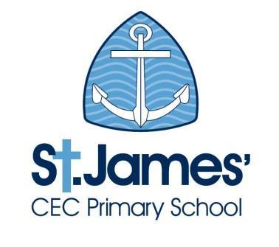
St. James’ CEC Primary School
Person Specification for post of Primary Teacher

E – Essential D - Desirable | How it will be assessed?
Application  - Well-structured supporting letter  - Fully supported in reference |  | Supporting letter  Application form  References  Interview
Qualifications and Experience  - Qualified Teacher Status  - A range of CPD experiences and achievements | E  D | Application form  References  Interview
Professional knowledge and Experience  - Successful teaching in a relevant environment;  - Experience of working with a range of ages;  - Ability to teach a full range of subjects;  - Ability to achieve the highest standards for all pupils;  - Knowledge of strategies to raise pupil achievement and attainment;  - Proven ability to identify barriers to learning and overcome them;  - Proven record of good relationships with children and parents;  - Leading a subject area  - Comprehensive knowledge of the National Curriculum and assessment;  - Ability to engage all abilities;  - Commitment to curriculum development;  - Strength in assessment, recording and reporting | E  D  E  E  E  E  E  E/D  D  E  E  E | Application form  References  Interview
Professional skills and attributes  - Excellent classroom practice that challenges and inspires;  - Excellent standards of positive behaviour management;  - Excellent communication skills;  - Good organisational skills;  - Willingness to attend and support events beyond the school day;  - High expectation of self and pupils  - Excellent people skills – motivating, nurturing and challenging pupils and adults to achieve their best.  - Commitment to safeguarding | E  E  E  E  E  E  E  E | Application form  References  Interview
Personal Characteristics  - Reliability with a high degree of integrity  - Approachable with excellent interpersonal skills when dealing with others on all levels  - Well-organised, enthusiastic and flexible  - Resilient and demonstrates the ability to work under pressure. Manages time effectively  - Values and respects the views of children  - Self-motivated and able to take initiative and responsibility  - A willingness to learn with and from colleagues  - Proactive in maintaining own professional development and can seek help from others when needed  - A commitment to take part in all aspects of the life of the School, including meetings, training, special events and other activities as required  - Adheres to school policy and procedures and supports our Christian ethos | E  E  E  E  E  E  E  E  E  E | Application form  References  Interview

