
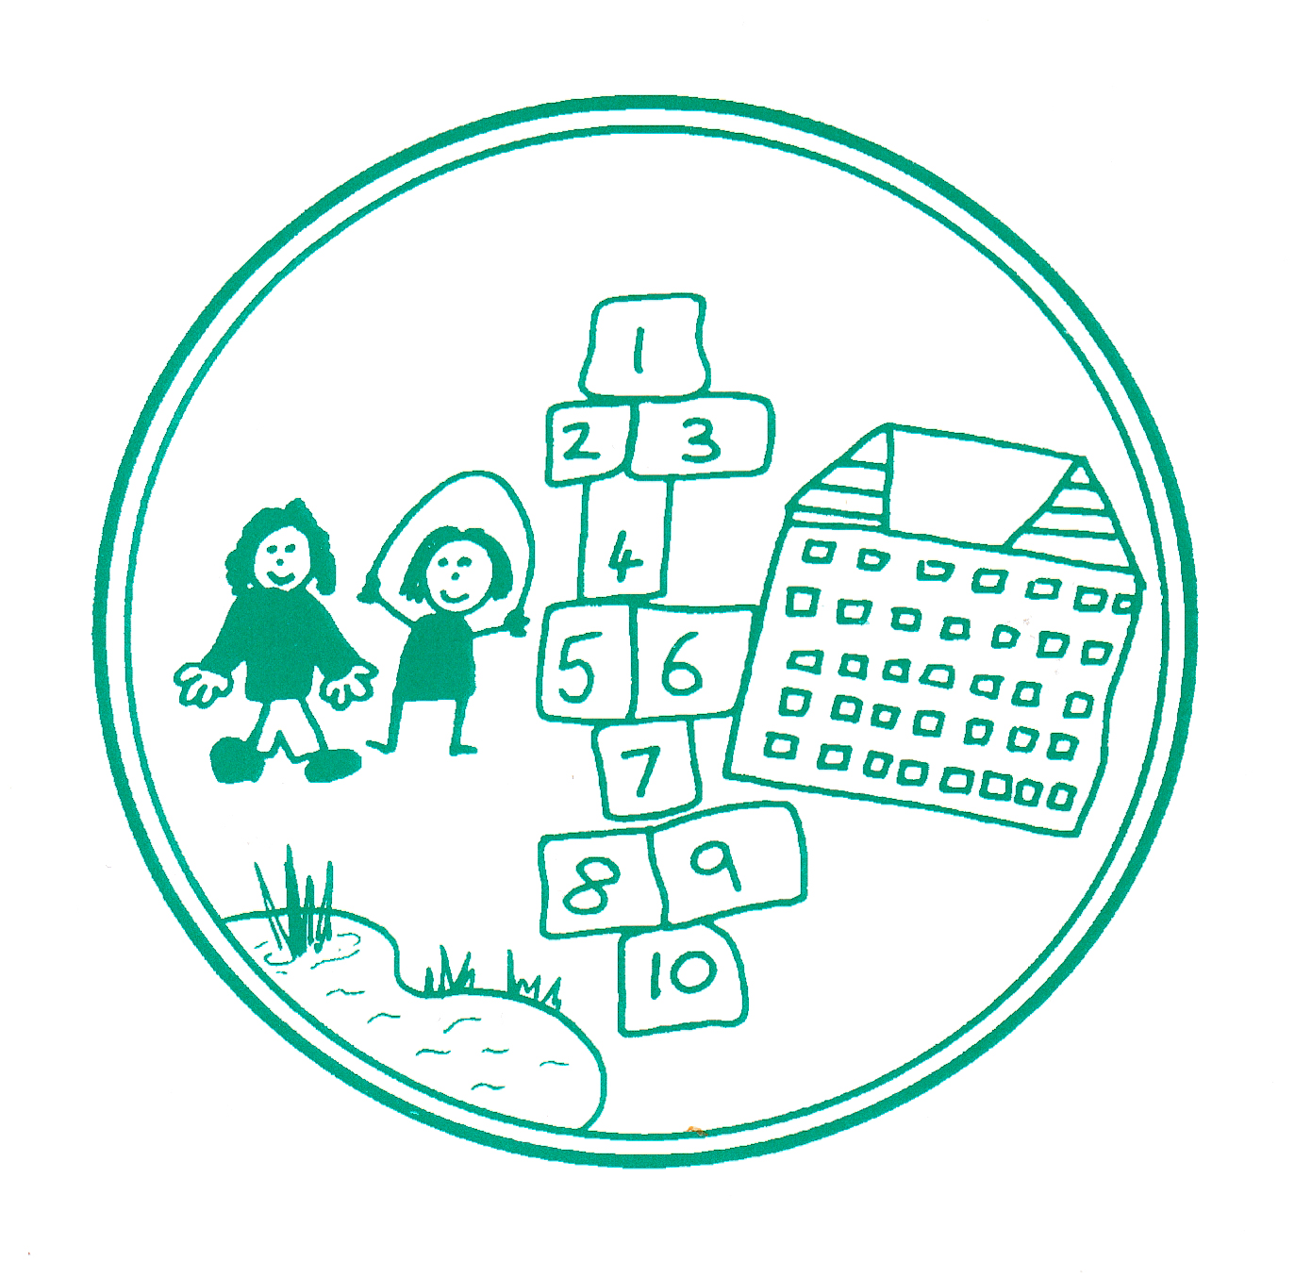


Shirley Infant School
PERSON SPECIFICATION - TEACHER

 | ESSENTIAL | DESIRABLE
PROFESSIONAL QUALIFICATIONS | - Qualified teacher status or equivalent qualification  - A clear DBS check | - Good honours degree 1 or 2.1
TEACHING COMPETENCY AND EXPERIENCE | - Successful teaching experience in KS1/Foundation Stage  - Ability to plan for personalised learning  - Early Years’ Foundation Stage or KS1 experience  - Knowledge of National Curriculum or EYFS and current assessment requirements  - Evidence of interest in active learning, creative curriculum  - Ability to articulate characteristics of high quality teaching and learning for all abilities  - Evidence of ability to promote and sustain high standards of behaviour  - Ability to reflect on own practice | - Interest in recent initiatives in teaching and learning  - Contribution to school activities outside the curriculum  - Inspirational use of ICT
LEADERSHIP QUALITIES | - Ability to organise & manage class, learning support assistants and work experience students | - Previous experience as a subject manager
PERSONAL QUALITIES | - Strong commitment to enabling children to learn.  - Approachable and caring attitude towards children  - Flexible and open to the ideas of others  - Willingness to learn, evidence of CPD  - Ability to give and receive support, prepared to ask for advice when necessary  - Ability to work in a team  - Strong relationships with colleagues, children and parents.  - Excellent organisational skills  - Good time management strategies | - Innovative and creative with the ability to inspire others  - Active outside interests  - Clear vision of own career development

Shirley Infant School is committed to safeguarding and promoting the welfare of children and young people and expects all staff and volunteers to share this commitment. We will ensure that all our recruitment and selection practices reflect this commitment. All successful candidates will be subject to Disclosure and Barring Service checks along with other relevant employment checks.

