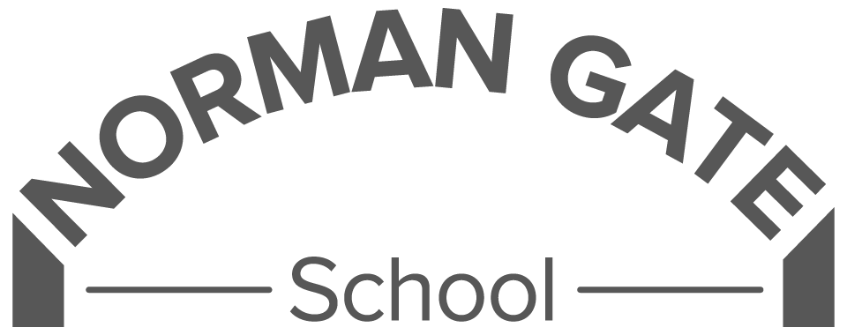
Play team member – Grade B

Context:
Norman Gate School is a day special school for children with a range of learning needs. The school ethos is one of nurturing support in a positive and fun environment where everyone is a learner and everyone is treated with respect. Priorities are raising self esteem and confidence, communication and self help/independence skills.
Everyone on the staff team is valued.

Under the instruction of senior staff work with individuals or groups to supervise physical, general care of pupils, including those with special educational needs, support access to learning and care needs for pupils and provide general support to the teacher in the management of pupils and the classroom.

Support for Pupils:
- Attend to pupils’ personal needs, including hygiene, health, first aid, and welfare.
- Establish positive, nurturing relationships with pupils, acting as a role model.
- Promote the inclusion and acceptance of all children regardless of background or ability.
- Encourage children to play, interact, and engage in play independently.
- Support development of communication, social skills, and self-esteem.
- Attend and participate in class and team meetings.
- Provide care, guidance, and advice to children throughout lunchtime.
- Record and report any incidents or safeguarding concerns according to school policy.

Lunchtime Play support
- Engage with children to create an enriching and safe play environment.
- Support communication regarding play needs and opportunities.

- Ensure risk management practices are implemented to support safe play.
- Promote inclusive and creative play experiences.
- Be aware of and adhere to health and safety regulations.
- Adapt to various play needs and changing environments.
- Facilitate and supervise enriching and inclusive play activities that meet varying needs.
- Engage with pupils actively during outdoor and indoor play.
- Coordinate safe transitions between play zones and the dinner hall.
- Assess play environments for safety risks and make adjustments as needed.
- Ensure equipment is safely set up, used, and stored.
- Adhere to health and safety regulations and safeguarding procedures.
- Work with the play coordinator and site staff to maintain and enhance safe play areas.
Support for the School:
- Appreciate and support the role of other professionals including working in a multi agency way
- Participate in training and other learning activities and performance development as required
- Follow policies on child protection, confidentiality, data protection, and health & safety.
- Promote the school’s ethos, vision, values, and rules.
- Work collaboratively with teaching staff and external professionals.
- Take part in school training, meetings, and performance development reviews.
- Support safeguarding as outlined in the Child Protection Policy and Keeping Children Safe In Education.

PLEASE NOTE: The Job Description may be reviewed at any time as necessary according to the needs of the whole school. Aspects of the job description will be an integral part of the Performance Management Review undertaken on an annual cycle. It may be amended at any time as an outcome of consultation between the Headteacher and postholder.

There is an expectation that all staff will ensure the welfare of the children by following the procedures in the Child Protection Policy, KCSIE and documentation related to the safeguarding of our pupils.

Signed……………………………………………………………………(Play team member)

Signed……………………………………………………………………….( Head Teacher)

Date…………………………………………………

