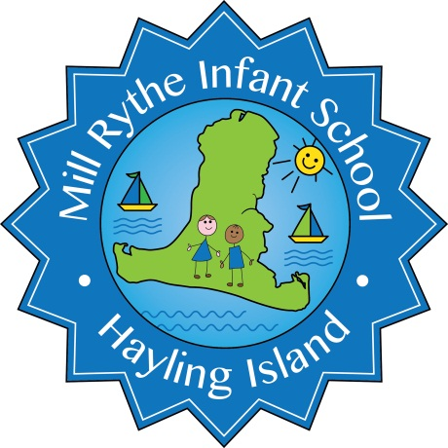

Mill Rythe Infant School
Administrative Assistant Person Specification

 | Essential | Desirable
Qualifications | - Qualified English and maths to GCSE Level C or above, or equivalent | - Recent professional development, further study and qualifications  - First Aid- Early Years Paediatric certificate
Administration competencies and experiences | - Excellent organisational skills  - Effective communication skills – verbal and written  - Ability to prioritise, plan and organise work  - Experience of maintaining efficient office systems, processes and procedures  - Providing administrative and secretarial support  - Data Protection – working confidentially | - Experience of admin work in a primary school  - Experience of working with parents and visitors in the best interests of the school  - Experience of performance management  - Knowledge of SIMS, Tucasi, Excel software  - Child Protection/Safeguarding
Personal qualities | - Is approachable and caring  - Shows a high level of commitment and enthusiasm  - Recognises when to seek advice and support and is prepared to do so  - Is reflective, creative and innovative  - Displays a constructive and optimistic attitude that has a positive effect on others  - Is self-motivated and able to motivate others  - Has excellent interpersonal skills and a presence which inspires confidence  - Make the welfare of pupils their first concern  - Accountable for achieving the highest possible standards in work and conduct  - Acts with honesty and integrity  - Building positive professional relationships  - Has a sense of humour | - Ability to self-evaluate learning needs and actively seek learning opportunities
Governors, Parents & Community | - Support and encourage parents to participate in the education of their children, | - Experience of working with other agencies.

