RIVERSIDE COMMUNITY SPECIAL SCHOOL 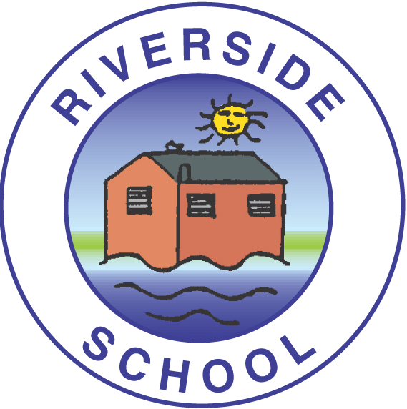

CLASS TEACHER - PERSON SPECIFICATION

ESSENTIAL  Training & experience in primary/Early Years education  Evidence of sound primary/Early years practice through successful performance management/observations  An excellent knowledge of the primary/early years curriculum especially the teaching of English, phonics & number skills.  A good understanding of how to work successfully with pupils who are within the Autistic Spectrum.  The desire to learn and develop as a professional.  An interest in/experience of working with children with learning difficulties  Excellent classroom management and organisation skills  A commitment to learn and adapt practice depending on the needs of pupils.  Good communication skills  An ability to understand and promote positive strategies for working with pupils who may have challenging behaviour.  The ability to work positively and professionally with parents in a sensitive and timely way  An understanding of the needs of pupils with complex learning needs, including non-verbal and pre- verbal pupils  The ability and commitment to working within a whole school team, including therapists and health professionals.  The ability to plan for a wide range of needs in a creative and structured way.  A belief in the ability of all pupils to make progress  A commitment to making a contribution to the life and development of the school.  A good understanding of the need to safeguard pupils (KCSIE)  Excellent ICT skills  A sense of humour. | DESIRABLE  Qualifications/training/experience in the special needs/learning difficulties field.  Teaching of early years curriculum  An understanding of Bucket Time  Skilled approaches to use with pupils with little or no communication skills.  Able to use Communicate in Print, symbols and communication aids  Experience of working successfully in a special school/special needs environment.  Prepared and able to drive the school vehicles  First aid qualifications  Experience in reviewing EHCP documentation

At Riverside School:
• We work together as a motivated and dedicated team to make a difference to our children, families and community.
• By placing wellbeing at the centre of all that we do, pupils are taught to manage their differences and flourish as individuals
• We provide a wide ranging and meaningful curriculum with an emphasis on communication and language skills
• Celebrating our achievements is really important to us.
• Governors act as critical partners, working with us to create the forward momentum for this outstanding school.

