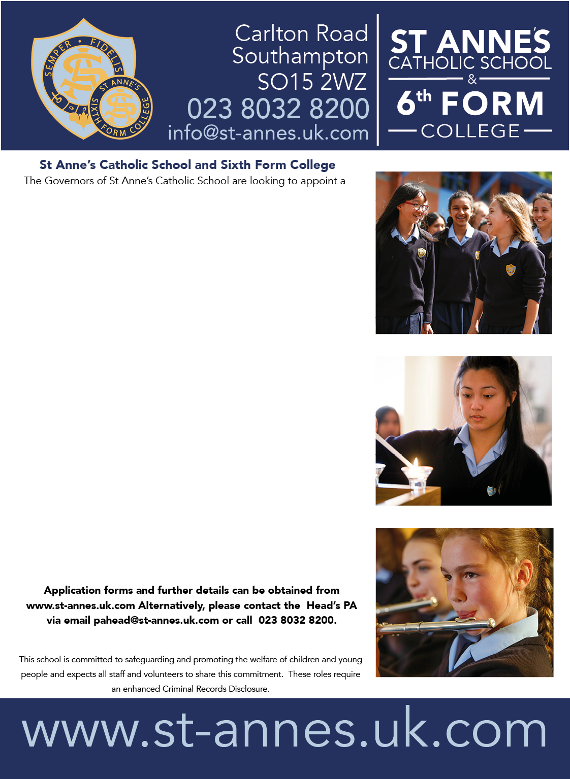
jjjjjjjjjjjjdd
The governors of St Anne’s Catholic School seek to appoint a full time enthusiastic and effective teacher to the role of Head of Year.
St Anne’s is a highly successful 11–16 girls’ school with a mixed sixth form in the heart of Southampton. Rated outstanding in all areas by Ofsted, our Catholic ethos shapes our commitment to placing staff wellbeing at the centre of every decision we make. Our strong outcomes reflect the positive and successful learning experiences this creates for our pupils. Staff and students consistently speak about the strong sense of community within the school, which is why colleagues tell us they enjoy working here and feel proud to be part of St Anne’s.
Specifics for this role
The Head of Year will establish a strong year-group ethos that supports students’ wellbeing, behaviour and academic progress throughout their five-year journey. They will lead and develop a team of tutors, promoting the school’s values through consistent, effective leadership. Working with other Heads of Year and Heads of Faculty, the post holder will monitor progress, identify trends and implement timely interventions for students who are underachieving. They will also oversee support for vulnerable students, including those at risk of suspension, those persistently absent, or experiencing emotional or medical difficulties. The ability to teach RE, Geography, Design and Technology, Art, Health and Social Care or Child Development would be an advantage.

Salary: MPR/UPR with TLR2c

Lorem ipsum
Lorem ipsum
Lorem ipsum

Required from 1 September 2026

LOREM IPSUM
LOREM IPSUM

Head of Year

Closing date: 27 April 2026
Interviews: Week Commencing 4 May 2026
The Governors of St Anne’s Catholic School are looking to appoint a
n

