SHAKESPEARE JUNIOR SCHOOL

GENERAL INFORMATION

ASPIRE
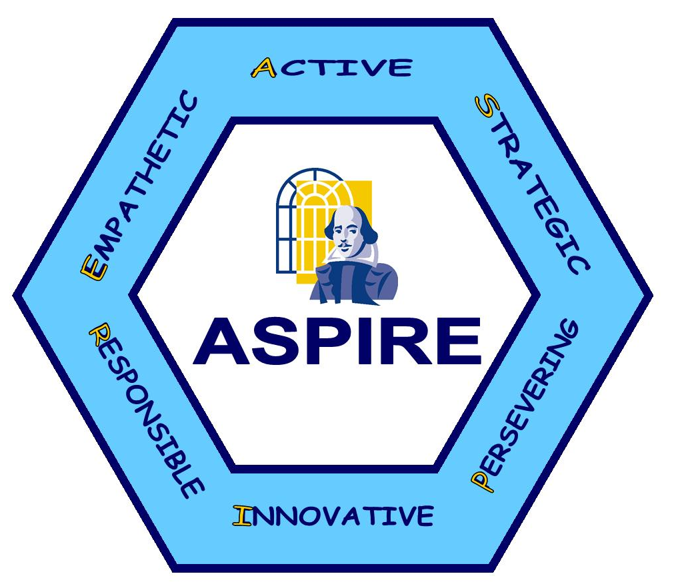

At Shakespeare Junior School, children and adults alike, follow our Core Learning Values and Aspire to be the very best they can. The children are familiar with the language of Being Active, Strategic, Persevering, Innovative, Responsible and Empathetic and work very hard to achieve their awards each year.

OFSTED

The school had an Ofsted inspection in June 2016. The inspectors judged Shakespeare Junior School to be a good school where –
- Leaders and governors have increased the quality of teaching, learning and assessment substantially since the previous inspection.
- Teaching ensures that pupils make rapid progress in their learning and in their personal development.
- Pupils enjoy talking about their achievements and are proud of their school. They behave sensibly and considerately.

SITUATION

The school is situated on Boyatt Wood Estate just to the north of Eastleigh town.

The original school was built in 1931 to serve a local authority housing area and was situated on a closed road. By 1976 the road had become a through road as part of a fast growing light industrial area and a large private housing estate. The new school, opened in 1976 to serve this expanding local population, was built on the same campus as the original school, which became a contributory infant school.

By 1980 the Crestwood Community Secondary School was opened to serve the area and a second infant school, Rookwood, was opened in the northern section of the estate. This school was also a contributory infant school. Rookwood closed in July 1997. In 1984 an extension to the school was built to cater for the increasing numbers coming through the Infant School.

THE SCHOOL BUILDING

The original school is of the Scola Mark 3 design. It was built as a 2 FE Junior School giving 9 classrooms for the 4 years of the junior age span (4 x 2 plus music room). The new extension to the school provides an additional 6 classrooms and a drama room, but as access to the extension is through one of the original building’s classrooms this gives a total of 14 classrooms. The new development of the school includes an Information Centre built into the central courtyard of the existing school and the original library area has become a resource centre and teacher preparation room.

In 2004 four temporary classrooms were removed and a purpose built 3 classroom extension was added to the school.

In 2016 we were lucky to have a replacement roof in the entrance area and we moved the administration offices to be more prominent, with a more secure entrance area.

PUPILS

The number on roll is approximately 350. Ages range from Year 3 to Year 6.

With the Boyatt Wood development our catchment has changed from approximately 75% Local Authority housing and 25% privately owned in 1970 to almost the reverse today. It is expected that numbers will increase significantly in the near future, hence the expansion project planned to complete in 2017.

STAFFING

At present the teaching staff consists of Head + 17. This includes full and part-time classroom based teachers, and a manager of the moderate learning difficulty resource provision. Within this complement are two Assistant Headteachers and a Year Leader for each year group, who make up our leadership team.

All staff take responsibility for school improvement by being part of a school improvement team. The current school improvement areas are -

Quality of Education – To enhance the curriculum, leading to improved outcomes.
Themes -
- Catch up curriculum
- Curriculum subject leadership
- Greater Depth Writing
- Spelling, Language and Vocabulary
- Reasoning in maths
- Pupil Premium outcomes

Personal Development/Behaviour and attitudes – To improve well-being for staff and pupils

Themes –
- Positive Behaviour Ethos, supporting children returning to school after lockdown.
- Personal Development curriculum, Behaviour for Learning and resilience
- Challenges – Outliers, inclusion and complex needs

Leadership and management – To continue to develop and improve leadership in all areas

Themes –
- Subject Leadership
- Governance
- New Leaders, including Subject leaders and Year group leaders

SECRETARIAL/ANCILLARY STAFF

There is one full time Admin Officer together with 2 clerical assistants to cover secretarial duties. In addition we employ a number of teaching assistants whose specific job is designated by the Headteacher together with the special needs department to give support to children with specific needs, to help implement interventions and to extend more able children. The school also employs a librarian and an ICT technician.

KITCHEN STAFF

The meals are prepared on site by 3 kitchen staff employed by HC3S.

CARETAKING

The school employs 1 full time site manager and 3 cleaners.

MEALS SUPERVISORY ASSISTANTS

A supervisory staff of lunchtime assistants takes responsibility for the children on site during the lunch break.

CLASS ORGANISATION

The school is organised into 4 year groups.

National Curriculum Year 3
National Curriculum Year 4
National Curriculum Year 5
National Curriculum Year 6

All classes are mixed ability and mixed sex. Setting is used in Numeracy according to ability.

TEACHING STYLES

To enable the teacher to cope effectively with a wide range of abilities, children are often taught in small teaching groups within the class. Other more extended groupings are used where appropriate. Groupings are usually class based but sometimes more flexibility allows groups within the wider parameter of the whole year structure. In order to rationalise both teachers time and experience, we can therefore make full use of subject specialists in various areas eg Music, Games and ICT Studies. Such organisational arrangements are left to the year groups to organise as they feel appropriate. This has involved setting the children across year groups.

ICT

The school is rightly proud of its development in ICT. All classrooms have Clevertouch touch screen white boards, there is an ICT suite and ‘pods’ of computers throughout the school. We also have a class set of ipads available for use to enhance the curriculum.

