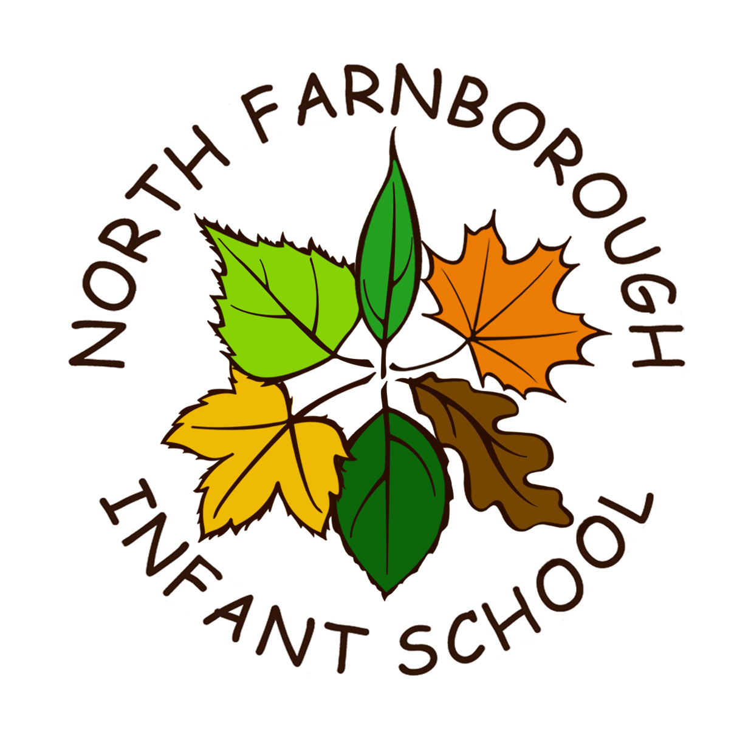
North Farnborough Infant School Rectory Road, Farnborough, Hants GU14 8AJ

Telephone: 01252 544606
www.nfis.hants.sch.uk
email: adminoffice@nfis.hants.sch.uk

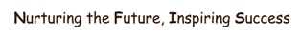

Head teacher – Miss Abigail Morgan

Welcome to North Farnborough Infant School

Dear Applicant

I have the pleasure in enclosing an application pack for the post of Class Teacher. Within this application pack, you will find a person specification and a job description.

Applicants should complete their application with a supporting statement, which should not exceed 2 sides of A4 paper. Any gaps in previous employment must be explained. Please submit applications to school by 12 noon by the closing date 15th May 2025.

As mentioned in the advertisement, an ENHANCED DBS disclosure, and a section 128 check are required for this post. It is important to note that North Farnborough Infant School is committed to safeguarding and promoting the welfare of children.

Thank you so much for your time and interest. I can be contacted by telephone - 01252 544606, if you require any more information.

Yours faithfully,

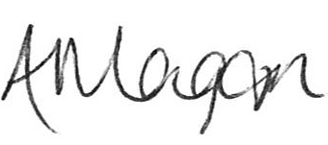

Abigail Morgan
Headteacher

