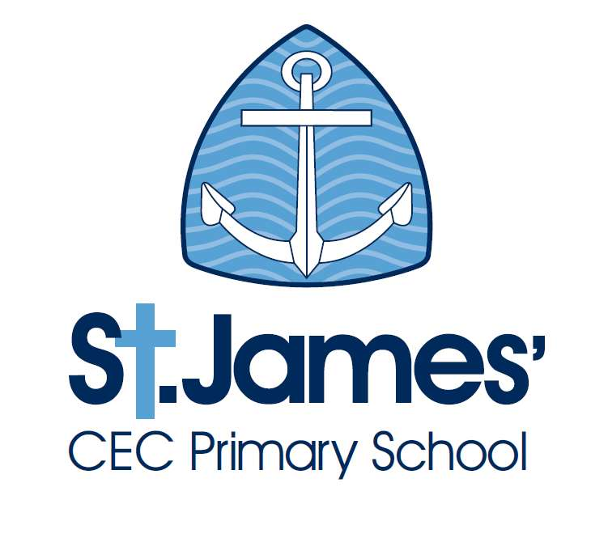
St James’ CEC Primary School

Person Specification: Administration Assistant

 | Essential | Desirable
Qualifications | - English and Maths to GCSE level or equivalent  - Training in the use of Microsoft applications: Word and Excel | - Comprehensive training in IT applications to include databases and publishing  - First Aid qualification
Experience | - Working in a busy environment and being able to multi-task.  - Experience in producing a variety of documents using different IT applications eg. letters, newsletters, signs  - Experience in compiling and sending communications via text, email and letters to multiple parties | - Working in a school/nursery setting  - Working with children  - Administering first aid  - Working as front of house for an organisation
Knowledge and understanding | - Competency in using Microsoft Word to produce letters using mail merge and a variety of publications  - Competency in using Microsoft Excel to produce spreadsheets for use as databases, mail merge bases and to collate and sort information  - Knowledge of confidentiality and data protection legislation and procedure.  - Ability to learn new IT systems quickly and be able to use them to full use to run reports, collate and store information  - An understanding of safeguarding in schools and the issues surrounding working with children  - Confidence in meeting and greeting visitors to the school in a professional and welcoming manner | - Experience in using the SIMS management information system  - Experience in using TUCASI software  - Previous safe guarding training
Skills | - An ability to learn fast and be able to apply skills learned immediately  - Ability to multi task and be able to prioritise quickly  - Be able to design and produce badges and signage using Word and laminators.  - Ability to work efficiently and tidily  - Able to work accurately despite interruptions  - Excellent communication skills | - Ability to use and troubleshoot office machines (mainly photocopiers and printers)
Personal characteristics | - Friendly  - Confident  - Communicative  - Organised  - Calm  - Empathetic  - Enjoy working in a team and with children | - Have a good sense of humour

