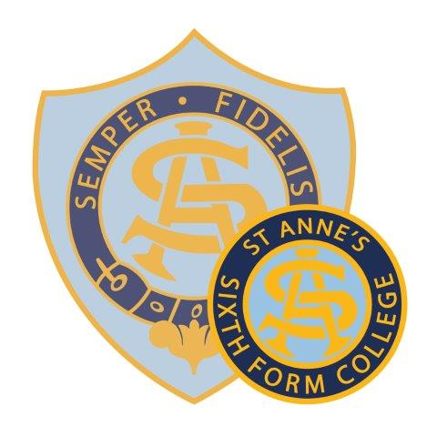
St Anne’s Catholic School

Person Specification for First Aid Manager

All staff appointed to St Anne’s are expected to be committed to
supporting the school’s Christian ethos and values.

Essential | Desirable
Relevant training | Qualification in training others for first aid
 | Professional qualifications and registration with relevant professional body (where relevant)
Person-centred approach.
Experience of relevant work with 11–16-year-olds. | Experience of working with 16-19 year olds.
Experience of supporting adults and relevant work with adults. | Relevant experience in an education setting.
Understanding of the safeguarding of young people. | Understanding safeguarding protocols in a school.
Experience of working with other agencies. | Experience of acting as lead professional in work with other professionals.
Ability to motivate young people, parents and staff.
Good IT skills, including the use of Word and Excel | Knowledge of IT packages used in a school setting
Ability to communicate with a range of different people both verbally and in writing, understanding the audience for the communication | Experience of delivering training.
Communicate in a skilled and sensitive manner, both verbally and in writing.
Demonstrate an aptitude for accuracy and detail.
Familiar with and works within code of professional conduct and ethics.
Committed to being a full part of the school community.
Ability to work independently and manage priorities and caseload.
Ability to carry out the roles listed in the job description. | Experience of carrying out the roles listed in the job description.

The successful candidate will be an adaptable and flexible team member who is discrete, calm and efficient with a sense of humour. They will be smartly-presented with IT skills suitable to the role.

