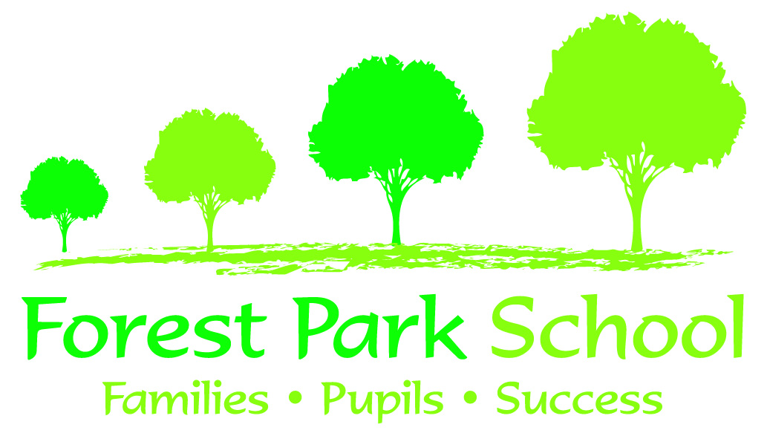
Forest Park School
Learning Support Assistant (Grade B)
Person Specification

Criteria | Essential | Desirable
Basic literacy and numeracy | ✓
Good communication skills | ✓
Empathy with children | ✓
Confident to work with individuals or small groups of children | ✓
Experience of dealing with various behaviours consistently |  | ✓
Experience of helping with learning activities | ✓
Ability to work independently and with initiative | ✓
Good organisational skills | ✓
Ability to motivate and encourage children appropriately | ✓
Ability to establish and maintain good relationships and rapport with other colleagues | ✓
Physically and emotionally suited to working in an environment involving manual handling, challenging behaviour and personal hygiene of pupils | ✓
Experience of working with children with moderate, severe or profound learning difficulties |  | ✓
Flexible and positive in relation to tasks undertaken and groups/children allocated | ✓
Commitment to training | ✓
Specific skills such as knowledge of Makaton, manual handling, tube feeding, epilepsy, simple communication aids, Team Teach/positive behaviour management strategies, PECS and TEACCH to support learning |  | ✓
Experience of completion of records and assessments for children |  | ✓

