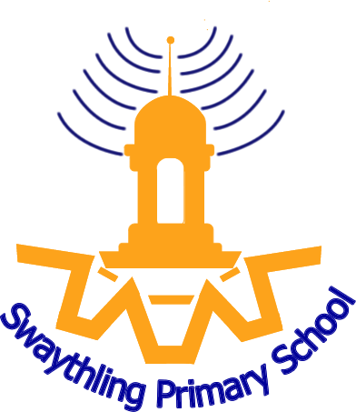

JOB DESCRIPTION

School: Swaythling Primary School | Location:
Job title: Class teacher  (Primary) | Salary range: Mainscale

The responsibilities of the post are to be performed in accordance with the provisions of the most up to date edition of the School Teachers’ Pay and Conditions document and within the range of teachers’ duties set out in that document.

Job Purpose
To carry out professional duties and to have responsibility for an assigned class.
To be responsible for the day-to-day work and management of the class and the safety and welfare of the pupils, during on-site and off-site activities.
To promote the aims and objectives of the school and maintain its philosophy of education.

Main duties and responsibilities
- To create and manage a caring, supportive, purposeful and stimulating environment which is conducive to children’s learning.
- To plan and prepare lessons in order to deliver the National Curriculum ensuring breadth and balance in all subjects.
- To identify clear teaching objectives and learning outcomes, with appropriate challenge and high expectations.
- To maintain good order and discipline among the pupils, safeguarding their health and safety.
- To organise and manage groups or individual pupils ensuring differentiation of learning needs, reflecting all abilities.
- To plan opportunities to develop the social, emotional and cultural aspects of pupils’ learning.
- To maintain a regular system of monitoring, assessment, record-keeping and reporting of children’s progress.
- To prepare appropriate records for the transfer of pupils.
- To ensure effective use of support staff within the classroom, including parent helpers.
- To participate in staff meetings as required.
- Contribute to the development and co-ordination of a particular area of the curriculum.
- To be part of a whole school team, actively involved in decision-making on the preparation and development of policies and programmes of study, teaching materials, resources, methods of teaching and pastoral arrangements.
- To ensure that school policies are reflected in daily practice.
- To communicate and consult with parents over all aspects of their children’s education – academic, social and emotional.
- To liaise with outside agencies when appropriate eg. Educational Psychologist.
- To continue professional development, maintaining a portfolio of training undertaken.
- To meet with parents and appropriate agencies, to contribute positively to the education of the children concerned.
- To support the Headteacher in promoting the ethos of the school.
- To promote the welfare of children and to support the school in safeguarding children though relevant policies and procedures.
- To promote equality as an integral part of the role and to treat everyone with fairness and dignity.
- To recognise health and safety is a responsibility of every employee, to take reasonable care of self and others and to comply with the Schools Health and Safety policy and any school-specific procedures / rules that apply to this role.

An annual review of this job description and allocation of particular responsibilities will take place as part of the Performance Management Review.
PERSON SPECIFICATION

School: Swaythling Primary School |  | Location:
Job Title: Class teacher  (Primary) |  | Salary range: Mainscale
KEY CRITERIA | ESSENTIAL |  | DESIRABLE
Qualifications and Experience | Qualified teacher status |  | A degree or equivalent qualification  Evidence of in service professional development
Knowledge  (Knowledge, abilities, skills, experience) | A thorough up to date knowledge of the range of teaching, learning and behaviour management strategies and how to implement them effectively.  A thorough understanding of the national curriculum and a range of assessment requirements and arrangements.  Know how to use local, national and statistics to evaluate the effectiveness of teaching.  Knowledge and understanding of the implications of equal opportunities, multicultural education and inclusion.  Knowledge of computer software relevant to the curriculum  Knowledge and understanding of the potential of computer technology to enhance the curriculum.  Know the legal requirements, national policy and guidance on the safeguarding of children. |  | Thorough knowledge and understanding of the National Curriculum, Foundation Stage and National Strategies for Literacy and Numeracy
Skills and Abilities | Ability to prepare and plan effectively.  Good organisational skills  Ability to prioritise and management time effectively.  Ability to work as part of a team
Work-related Personal Requirements | Suitability to work with children.

