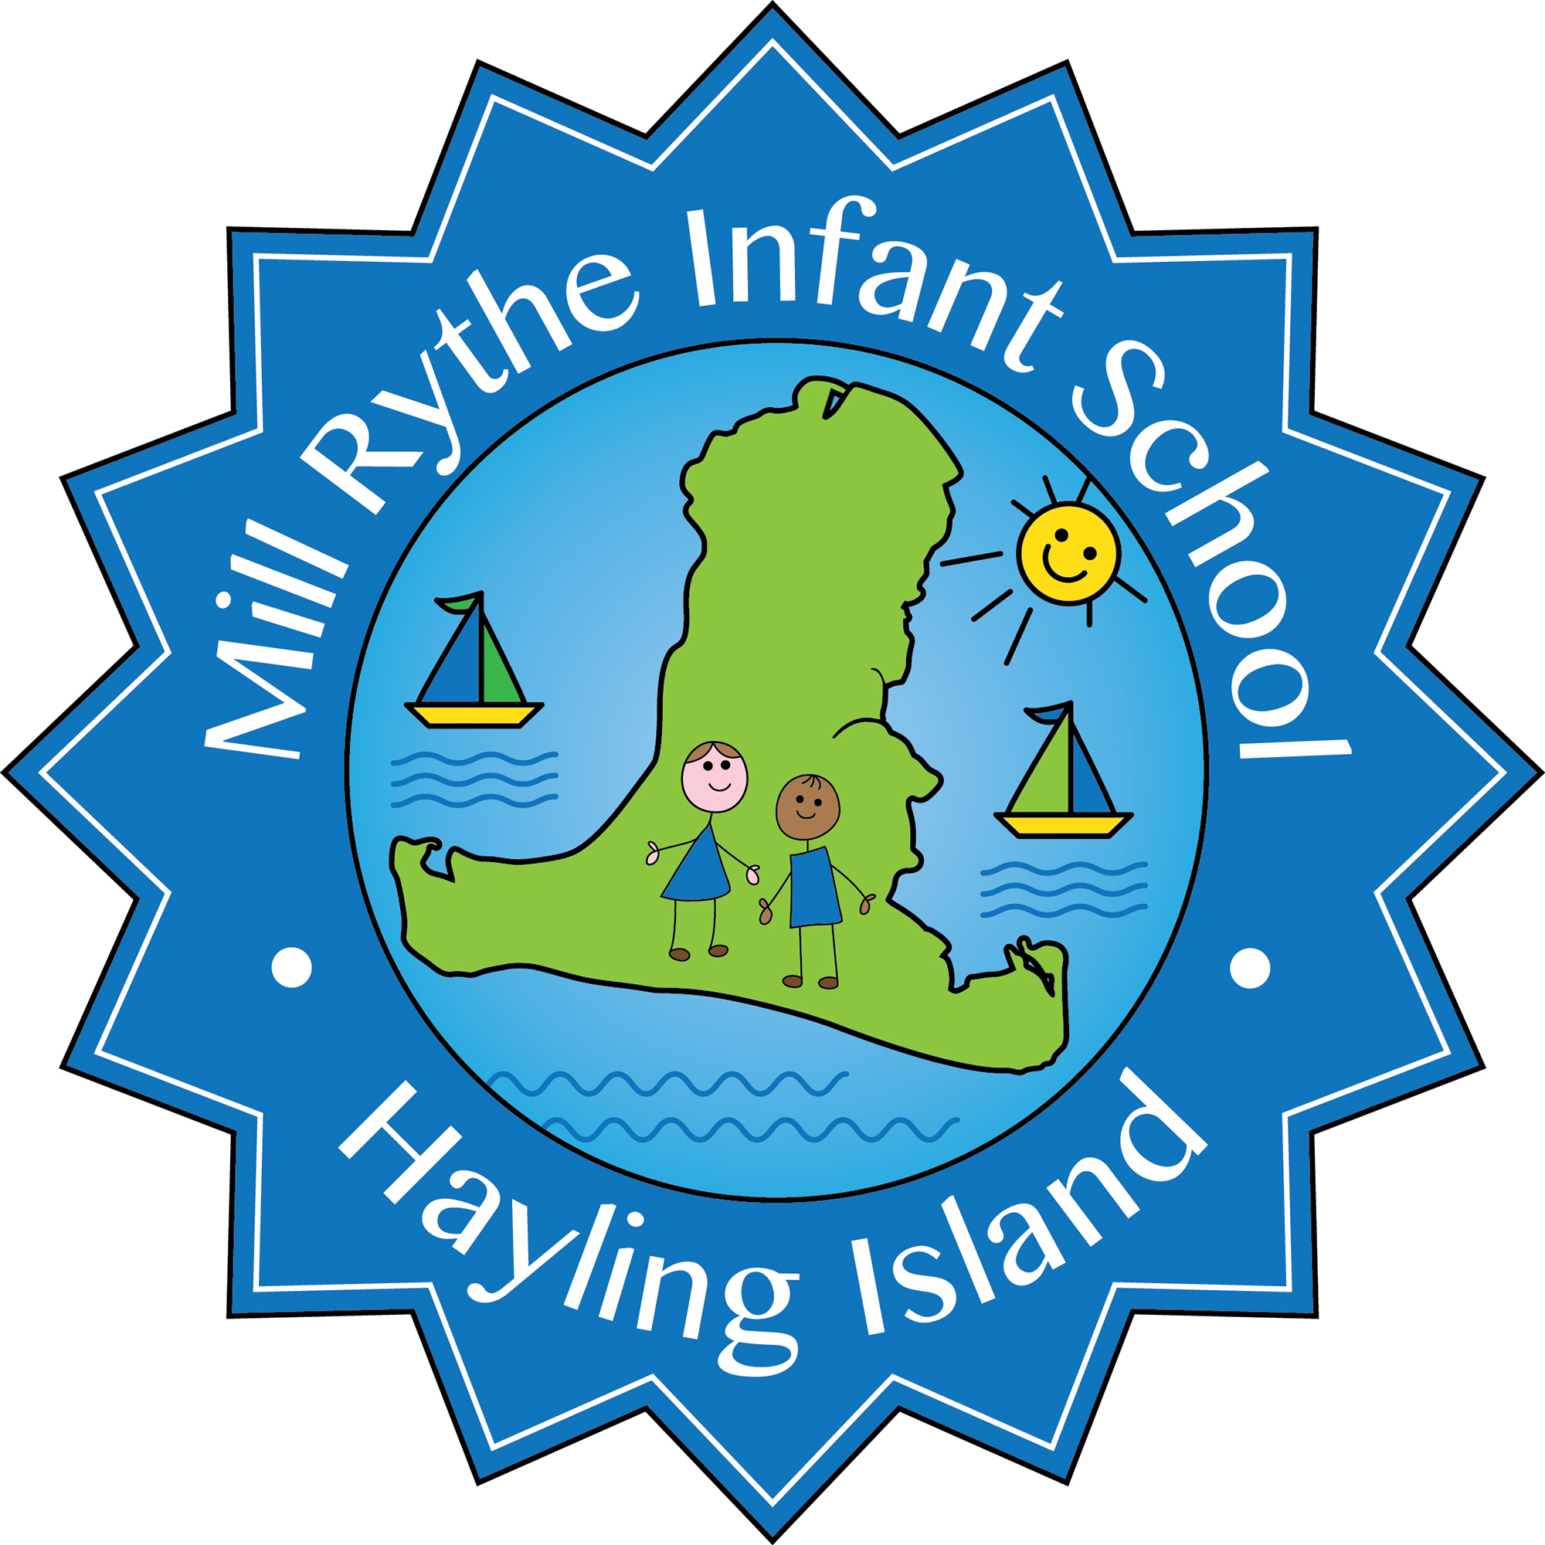
MILL RYTHE INFANT SCHOOL
Person Specification

Post Title: Learning Support Assistant Level 2 (1-1)
Hours: Full-time

 | Essential | Desirable | Source of Evidence
Education and Training  - GCSE English and Maths A-D qualifications  - NVQ2 for Teaching Assistants or an equivalent qualifications |  | *  * | A  A
Experience  - Successful experience as a TA  - Experience delivering interventions  - Experience working 1-1 with a child with additional needs | *  * | * | A/I/R  A/I
Knowledge and Understanding of:  - Attachment and Trauma  - The National Curriculum  - Promoting the safeguarding of all pupils  - High Quality Inclusive teaching  - Using the environment to engage and enthuse learners | *  *  * | *  * | I  A/I  I  A/I  I
Skills  - The ability to support pupils who are vulnerable and a commitment to inclusion and equality of opportunity for all pupils  - Supporting children in their learning, under the guidance of a teacher  - Reflecting on sessions alongside their class teacher to identify next steps.  - The ability to work successfully in a team  - Good organisational skills  - Good interpersonal skills with adults and children  - Ability to establish effective and confidential relationships with children, parents and outside agencies  - Maintain records and provide feedback to their class teacher, SENCo or inclusions team | *  *  *  *  *  *  *  * |  | A/I  A/I  A/I  A/R/I  A/R/I  A/R/I  A/I  A/I  A/I
Personal Qualities  - Nurturing and caring  - Motivated and committed  - Patient and organised | *  *  * |  | I/R  I/R  I/R

Sources of evidence: A= Application R=Reference I=Interview

