
Whitchurch C of E Primary School, Daniel Road, Whitchurch, Hampshire, RG28 7LS
Tel: 01256 892755
Email: adminoffice@whitchurch.hants.sch.uk

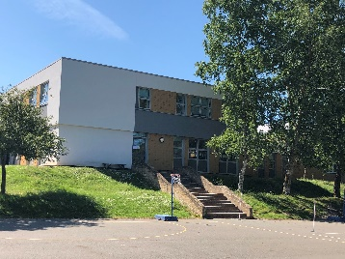
Whitchurch C of E Primary is a two-form entry school with 403 pupils, judged as continuing to be “good” by Ofsted in February 2025. The school is in the heart of the Test Valley with close links to Winchester, Basingstoke, Andover and Newbury. The school is arranged into teams; Early Years, Key Stage 1, Lower key Stage 2 and Upper Key Stage 2. Each team is led by a Phase Leader who is part of the Leadership team along with the Deputy Head Teacher, Head Teacher and SENCo. The school has a strong team of LSAs to support children with additional learning needs.
The Community
Whitchurch CE Primary is very much a community school. It is the only primary school in Whitchurch and although it is now quite a large school, it has kept its family feel. The in-take of pupils reflects a complete cross-section of the community. The children are a pleasure to teach and be with. They like learning, are high achieving and are very successful. The parents are welcoming and are keen to support their children with their learning. There is a strong PTA and governors who enjoy being involved in the school.

School Values
The school motto is “Together we make a difference through love, courage and respect”. We use our Christian values to help us develop children’s life skills, ensure their well -being and influence the curriculum. We are a church school and put the children first, catering for all faiths and none. We are committed to ensuring that our school makes a real difference to the educational outcomes of the children and the quality of their future lives. This can be achieved through a curriculum which is stimulating and engaging and an environment that is both challenging and nurturing. We firmly believe that children should be taught key skills and knowledge and given the opportunities to practice these in effective and imaginative ways. We believe a child’s sense of self-worth is paramount in their ability to learn and our team work hard to create a climate in which children can flourish. We promote an environment which is positive and caring.

School Site and Accommodation
The school moved onto its present site in 1973 and occupies an attractive open position adjacent to the River Test. There are extensive playing fields and playground areas. The school building has been recently refurbished to provide modern learning facilities. In addition to classrooms there is a music room, hall, studio, library, Thrive room, PPA/meeting room and shared work areas. Year 2 are currently sited in a temporary classroom block.

Teaching at Whitchurch
There is a good mix of teachers some who are progressing on their teaching career alongside many experienced teachers. They are a strong, professional, friendly, supportive and sociable group. The teachers plan in teams, share resources and offer support. All teachers have generous PPA time and ECTs have additional time. We recognise that our staff are our most precious resource and professional development is important for everyone. CPD is carefully planned to support subject knowledge and the school development. Everyone is encouraged to keep learning!

Staff Training
We use our five INSET days wisely to develop our skills. INSET days this year have been on developing Curriculum and Phonics. We have an hour staff meeting once a week where we either explore an aspect of teaching or share ideas in our teams.

School Opening and Closing Times
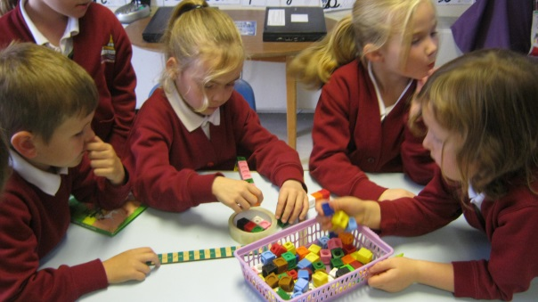
The site manager opens the school at 7:00 am and closes it at 6:30 pm.

Asking for help
The staff at Whitchurch CE Primary are very friendly, so please do not hesitate to ask them any questions about school that you may have. All new staff are given a mentor, and their key stage manager will also ensure that new staff are well supported.

Focus Assemblies and Productions
In the Autumn term each class prepares a short (5 minute) contribution to harvest festival. In the Spring and Summer Terms classes take turns to prepare a short collective worship to present to the parents. The younger year groups prepare plays at Christmas time. We visit the All Hallows Church once a term for a short service.

Special Events
The school plans many exciting events for the children to ensure the curriculum is vibrant and interesting. Some events happen annually such as World Book Day and other charity events. Sports Day is a big event for children and their families in the Summer Term.

Visits and Visitors
The school encourages teachers to organise visits and visitors to enhance the curriculum. Classes are encouraged to use our wonderful school grounds and the locality as well as journeying further afield. Children in Year 4 and 6 have residential visits. We are proud of our links to Mityana Junior School in Uganda and fund raise and communicate with them as much as possible.

Forest Schools
Forest School is an important part of our curriculum offer as the children enjoy working in the natural environment. Children in Years R to 3 have Forest school.
If you are looking for a new teaching or learning support post, I do hope you will consider Whitchurch CE Primary School. There is so much more to learn about our school and I or one of my colleagues will be very pleased to show you around, so you can ask specific questions.

I look forward to meeting you

D Ware

David Ware
Head Teacher

