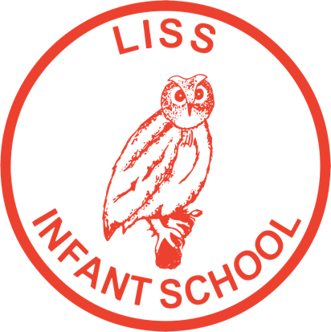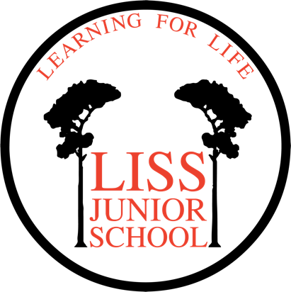

Federation of Liss Infant and Junior Schools

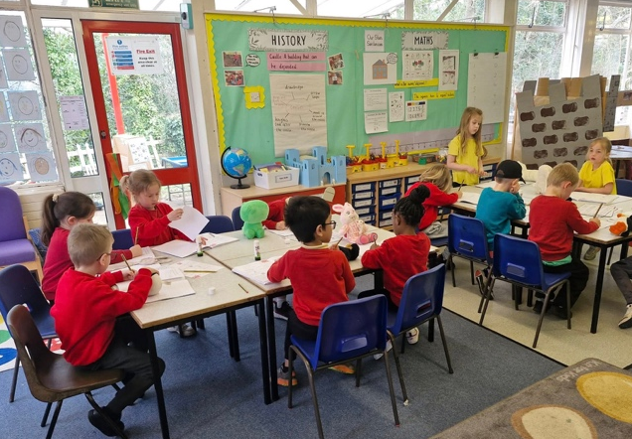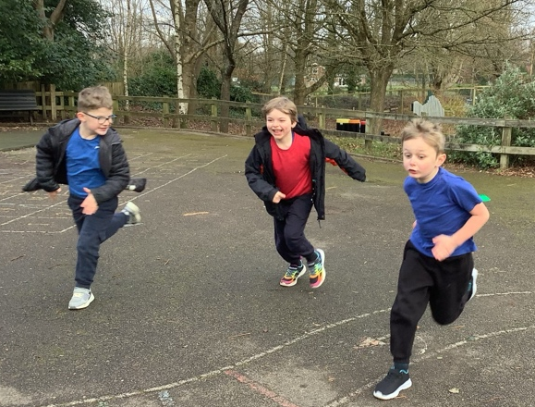
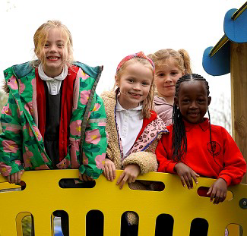

Headteacher

Required for September 2026

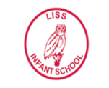
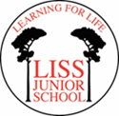
Federation of Liss Infant and Junior Schools
Interim Headteacher: Mrs K. Bowen

Hillbrow Road, Liss, Hampshire GU33 7LQ
Tel: 01730 892666 / 892292

E-mail: office@lissinfant.hants.sch.uk info@lissjunior.hants.sch.uk
Website: www.lissfederation.hants.sch.uk
__________________________________________________
Tuesday 3rd March 2026
Dear Prospective Applicant,
Thank you for your interest in the vacancy for Headteacher at the Federation of Liss Infant and Junior Schools. This is an exciting opportunity for someone wishing to demonstrate next-level leadership in education at a Federation with inclusion at its heart and high ambition for all its pupils.
We are seeking an outstanding and successful leader who will work in close partnership with the Deputy Headteacher, SENCO and all staff across both schools, to continue to promote high standards of teaching and learning for all pupils and who will oversee and advance on-going and embedded school improvement. Ideally, they will have experience in leading a school with a Resourced Provision and in balancing strategic and hands-on demands.
Should you have any questions, please call or e-mail us and we will answer them as quickly as possible.
Please ensure that you upload your application form by noon on 13th April 2026.
Please use the application form to highlight how you meet critical elements in the Job Description and Person Specification.
We look forward to hearing from you.
Best wishes

Zoë Webster
Chair of Governors

Information for Applicants

Our vision
At the Federation of Liss Infant and Junior Schools, we nurture a love of life, love of learning and mutual respect. We aim to provide a stimulating and challenging environment where everyone is happy, valued and every voice is heard. Children leave our schools equipped with the skills to become valued and responsible members of the community with a love of learning.


The pupils of Liss Federation
There are currently 83 pupils in the Infant School and 187 pupils in the Junior School. Both schools have a Resourced Provision – these cater for children with moderate learning difficulties and are very much at the heart of our school community. We aim that children within these provisions enjoy at least 50% of their learning with their mainstream peers.
Our children are keen to learn, and they enjoy coming to school. We are fortunate to receive strong support from the parents, community and our committed team of governors. We are working on further improving teaching and learning to ensure that every child makes good progress and achieves their full potential.
The Infant and Junior School each have a student council that discuss relevant issues to the students as well as facilitating the efficient running of events, The councils are sometimes consulted on potential purchases that will benefit the school.
The Federation has a set of strong and embedded core values around Respect, Inclusion, Care and Cooperation and Honest (RICH) and these are recognised by pupils. When asked what they most like about their school, pupils have mentioned the feeling of responsibility they have and the fact they can be themselves. Children report feeling safe.

When asked about qualities they are looking for in an headteacher the children say:
- Someone who is respectful and a good role model
- Open to the ideas of all, and listens to children and staff
- Takes time to talk to children (unless they are really busy) and smiles.
Children would like a headteacher to:
- Increase the number of clubs available to them
- Find ways to use the outside space more in lesson time.


Key features of Liss Federation
The Federation was established in September 2018. We are a two-form infant and junior school situated on the same site just out of the centre of the semi-rural village of Liss in East Hampshire. Located within the South Downs National Park and close to the Surrey and Sussex borders, with excellent transport links and good amenities. There is a friendly and thriving community atmosphere within the village which is evident through the school community also. Together, the two schools can accommodate 440 pupils, and they benefit from extensive grounds which have a variety of habitats including wooded areas, open field and hard surfaced play areas. New interactive play equipment for the Infant school was installed in September 2025.
Liss Infant School opened in 1971 and has semi-open classrooms in year groups, enabling year teams to work closely together. It has a 10-space Resourced Provision for pupils with moderate learning difficulties which opened in January 2020.
Liss Junior School opened at its present site in 1994 and is housed in a relatively modern building with spacious learning areas and an open plan feel that promotes an atmosphere of togetherness through the years. Since December 2016, a Resourced Provision has taken a central position in the school, providing 12 spaces.
For more information about our two Resourced Provisions, please see: https://www.lissjunior.hants.sch.uk/Info/Resourced-Provision/
The Federation enriches provision in the schools using partner organisations. For example, we use the services of CM Sports to provide a varied curriculum of sports programmes throughout the year in all year groups. ‘Commando Joe’ is used to help pupils build critical life skills such as resilience, teamwork and self-confidence. The school has a strong musical tradition, and the children benefit from peripatetic music teachers from Hampshire Music Service and the external company iRock as well as a teacher led choir. Both schools work with our twinned school, Kafuro Primary, in Uganda.
The Federation is supported by an active PTA group who raise funds through engaging events and provide access to good-quality second-hand school uniform for families who can benefit.
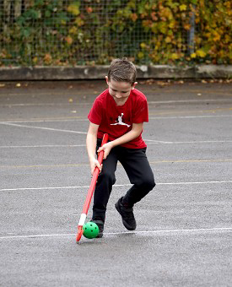

The staff of Liss Federation
Although we are two distinctive schools, we have the feel of a large primary school. Our senior and middle leaders work across the Federation, working as one team with dedicated improvement plans.
The staffing team are a committed mix of LSAs, recently qualified and experienced teachers who work closely under a clear and committed leadership team who promote a supportive and focused ethos. The Federation has strong systems for pastoral support and behaviour management based on relational models which have recently been reviewed and developed with all staff.
The leadership structure includes a full-time Deputy Head and a full-time SENCO. This offers the Federation excellent leadership experience and provides capacity to drive and embed continuous improvement.
The Federation serves children and their families from a range of socio-economic backgrounds and the families of Liss Federation benefit from a high skilled full-time Home-School Link Worker. All qualified teachers lead a curriculum subject from Early Years through to Year 6. Planning and evaluation are collaborative across the Federation. PPA is allocated so year groups can plan effectively together.
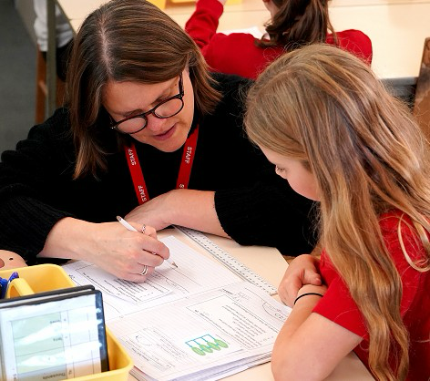

Leadership structure
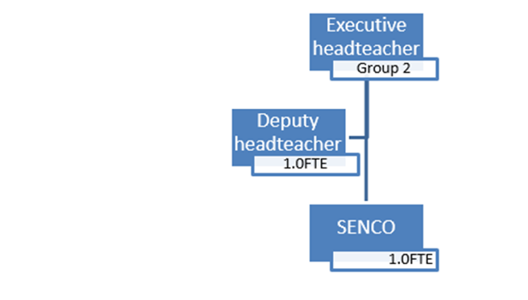
Class structure (2025/26 numbers shown)
The following table shows pupils numbers across the class structure operating currently. It does not include children in the RP of which there are 10 in the Infant School and 12 in the Junior School.
Reception | Year 1 | Year 2 | Year 3 | Year 4 | Year 5 | Year 6
Wrens-11 pupils | Larks-20 pupils  Puffins-16 pupils | Swallows-26 pupils | Ash –34 pupils | Beech-21 pupils  Willow-20 pupils | Pine-22 pupils  Birch-21 pupils | Rowan –29 pupils  Maple-28 pupils
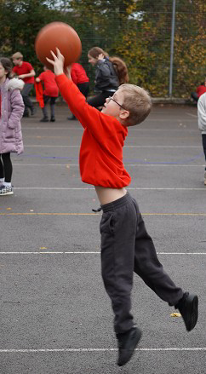
Work by staff to boost numbers in the Reception next year has paid off and we expect to run a full class in Reception next year. The Infant School is likely to be remodelled to work on a 1.5 class (45 PAN) basis in the coming years. This will support long-term planning and free up space for extra provision in both schools.
Ofsted
The Infant School was judged to be ‘Good’ in all areas following an Ofsted Inspection in July 2025.
The Lead Inspector reported that pupils are happy at school and take pride in helping each other. Leaders set high expectations for pupils’ behaviour and achievement as well as a culture of kindness. Recent improvements have driven positive change in the quality of curriculum and wider education at the school. Governors have a secure knowledge of how to check for school improvement. Pupils feel safe and secure, and they learn and behave well in school.
Areas highlighted for improvement:
- Consistency in teaching Phonics and support for early reading
- Attendance for some pupils
- Richness of the personal development programme for pupils with

The Junior School was judged to be ‘Good’ in all areas following an Ofsted inspection in March 2024.
Pupils develop ‘can-do’ attitudes in response to the school’s high expectations. Staff encourage pupils to try hard and persevere, especially when they find learning challenging. All pupils, including those with special educational needs and/or disabilities (SEND), learn to grapple with learning when it gets tricky. Over time, this helps pupils to develop increasing independence and self-confidence. This purposeful approach supports all pupils to enjoy learning and achieve well.
Teachers’ subject knowledge is secure across subjects. They use this to provide clear explanations and ask probing questions that check pupils’ understanding. Teachers promptly correct any pupils who have inaccurate understanding, so they can confidently apply new learning. Teachers use end-of-topic assessments to identify areas of knowledge where further teaching is needed. Staff know how to meet the individual needs of pupils well and use this knowledge to carefully adapt activities so that pupils, including those with SEND, learn effectively.
Areas highlighted for further improvement
- The school needs to ensure that staff support pupils to remember important knowledge over time in all subjects.
- The school needs to ensure that subject-specific vocabulary is taught with the same rigour across all subjects

Please find links to the full Ofsted reports here: https://www.lissjunior.hants.sch.uk/Info/Ofsted/

Latest set of published data (2025)
NB data includes pupils within the resourced provision units
EYFS
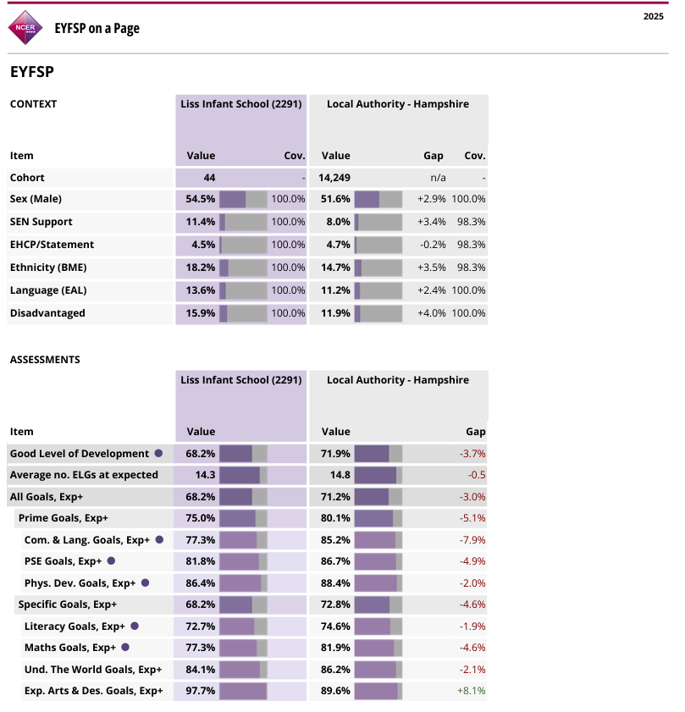

Phonics
Year 1 Phonics Screening
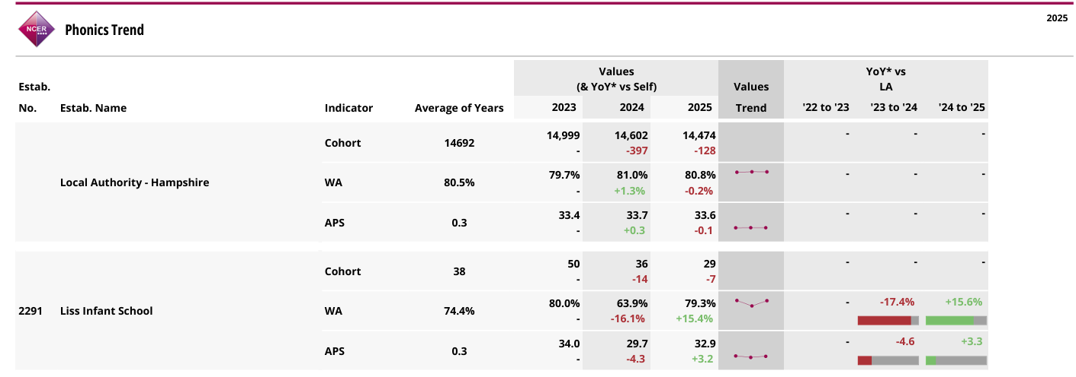

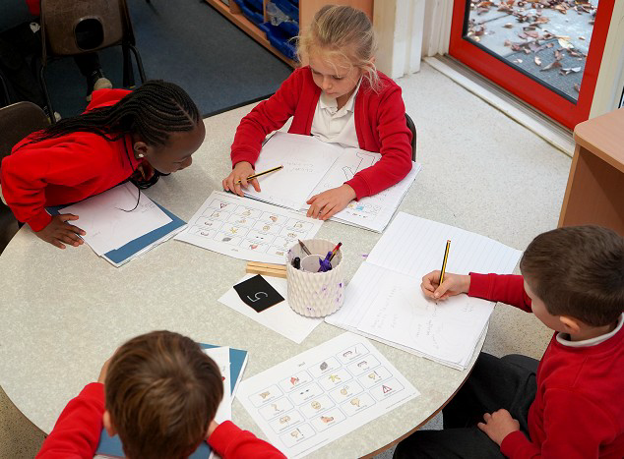

KS2
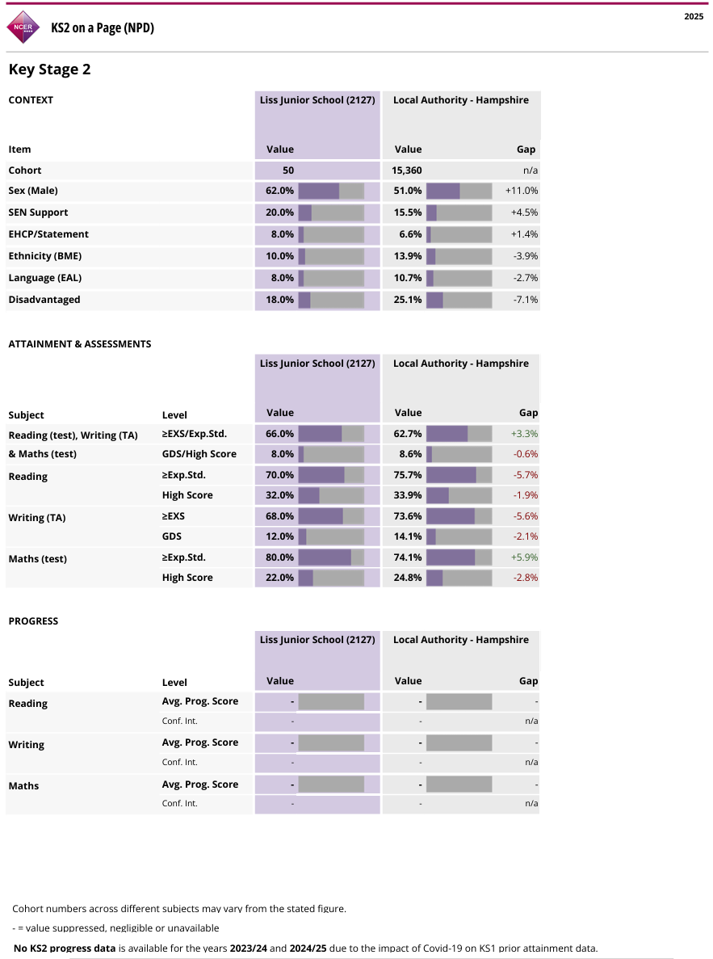

Focus areas for our new Headteacher

We have identified the following focus areas for our Headteacher during the next part of our journey:
We want to foster positive and reciprocal relationships with our families and the wider community for the benefit of our children, and to become the local school of choice for families.
What strategies have you used for this, and how would you develop this further?
We want to increase the effectiveness of leadership and governance to secure strong outcomes for all learners.
How will you ensure engagement and align the work of the whole team to achieve this?
We want every teacher to deliver consistently high-quality teaching, learning and assessment so that all groups of pupils achieve well.
How will you manage performance and resources to ensure that practice delivers effectively for all groups of learners?
We have worked hard to establish our intended curriculum and the knowledge and skills that pupils need in every subject.
How will you engage school leaders to further embed this work, enrich our curriculum and ensure our children know more and remember more?

These focus areas will be subject to a review, after appointment, with the governing body and Local Authority Leadership and Learning Partner to ensure that they remain the priorities for action.

Links to application process

The application statement should refer to the candidate’s consideration of these key focus areas and their relevant experiences, achievements, and skill against identified (A) elements of the person specification.

Federation of Liss Infant and Junior Schools Headteacher

SUMMARY JOB DESCRIPTION

Job Title: Headteacher

The Contract of Employment between the Governing Body and the Headteacher will be the current Contract of Employment for a Headteacher. The job description can be amended at any time, following consultation between the Headteacher and the Governing Body and will be reviewed annually.

Salary Scale: The Governing Body has determined that this post should be paid on the Hampshire agreed pay scale. The Federation of Liss Infant and Junior Schools is a Group 2 school. Governors have set the Individual Salary Range at L15–L21* (£73,105 - £83,860).

General job expectations and accountabilities: The Headteacher is an employee of the Governing Body and is required to carry out his/her professional duties in accordance with the terms and conditions of the current School Teachers' Pay and Conditions Document and relevant employment legislation.

Responsible to: The Governing Body of the Federation of Liss Infant and Junior Schools

Key responsibilities:

Safeguarding: The post holder will be the lead Designated Safeguarding Lead (DSL) and is responsible for ensuring that all school and county child protection policies are adhered to and concerns are raised in accordance with these policies

Financial Management: Advising the Governing Body on the schools’ annual budgets and the budget revision as appropriate, as well as being responsible for the day-to-day running of the budget.

National Standards Headteachers (2020)
The Headteachers' Standards form the basis of our Headteacher job description. They can be found at Headteachers' standards 2020 - GOV.UK (www.gov.uk)

Federation of Liss Infant and Junior Schools
Headteacher Person Specification

Your application statement should refer to your consideration of
the relevant experiences, achievements, and skills identified as A (application) below
and the key focus areas described in the job description

Core professional experiences, qualifications | Shortlisting evidence sought in application (A), reference (R) or interview (I)?
General:  - Is a qualified teacher with Qualified Teacher Status Essential  - Has a proven track record of success, and of managing change, as a senior leader (Head / Acting Head / Deputy Head / Head of School / Assistant Head) Essential  - Has experience of using a range of evidence, including performance data, to support, monitor, evaluate and improve aspects of school life, including challenging performance Essential  - Has knowledge and understanding of strategic financial planning, budgetary management and principles of best value Desirable  - Evidence of relevant professional study and/or qualification e.g. NPQH, MA Desirable | A  A  A, R, I  A, R, I  A
National Standards for Headteachers (2020)  Please tell us how, in your current and previous leadership roles, you: | Shortlisting evidence sought in application (A), reference (R) or interview (I)
Uphold ambitious educational standards which prepare pupils from all backgrounds for their next phase of education and life.  Establish and sustain consistently high-quality, expert teaching across all subjects and phases, built on an evidence-informed understanding of effective teaching and how pupils learn.  Establish effective curricular leadership, developing subject leaders with high levels of relevant expertise with access to professional networks and communities.  Establish and sustain high expectations of behaviour for all pupils, built upon relationships, rules and routines, which are clearly understood and owned by all staff and pupils.  Establish and sustain culture and practices that enable all pupils to access the curriculum and learn effectively.  Ensure staff have access to high-quality, sustained professional development opportunities, aligned to balance the priorities of whole-school improvement, team and individual needs.  Ensure the protection and safety of pupils and staff through effective approaches to safeguarding as part of the duty of care.  Develop appropriate evidence-informed strategies for improvement as part of well-targeted plans which are realistic, timely, appropriately sequenced and suited to the school’s context.  Forge constructive relationships beyond the school, working in partnership with parents, carers and the local community.  Understand and welcome the role of effective governance, upholding their obligation to give account and accept responsibility. | A, R, I  A, R, I  A, R, I  A, R, I  A, R, I  A, R, I  R, I  A, R, I  A, R, I  A, R, I
Hampshire Leadership Qualities and Behaviours  Please tell us how, in your current practice, you: | Shortlisting evidence sought in application (A), reference (R) or interview (I)?
Actively reflects on what works and what does not and uses the information to influence the way ahead and to make decisions.  Shows the ability and confidence to interact effectively with people in a range of contexts; understands the audience and the purpose of different relationships.  Has high expectations of herself/himself, staff and pupils to realise the full potential of the learning community.  Builds community relationships based on a mutual and collective responsibility with diverse partners, to create a high-quality learning environment for all. | R, I  R, I  R, I  R, I

APPLICATION PROCEDURE

To apply, download the attached application form by clicking the on the application form, then complete and save it. Once ready, click 'Apply' button to upload your completed application form. Please upload your application form no later than noon on Monday 13th April 2026.

You should provide a full statement in support of your application, which should not exceed two sides of A4 paper. Please do not restate the factual details already included elsewhere on the application form.

Selection Procedure

The shortlist will be drawn up on Wednesday 15th April and the selection process will take place on Tuesday 28th and Wednesday 29th April. Further details will be sent to those candidates called for interview.

Applicants will be advised within 3 working days after the shortlisting date whether they have been successful or not.

Failure to send your application form to the above email address may invalidate your application.

Equality Monitoring

All applications will be required to complete an Equality Monitoring form.

Receipt of Application

Applications are acknowledged within 2 working days of receipt. If you do not receive an acknowledgement within this time, please contact the Recruitment Team immediately at htrecruitment@hants.gov.uk

Safer Recruitment

The Federation of Liss Infant and Junior Schools and Hampshire County Council are committed to safeguarding and promoting the welfare of children and young people and expect all staff and volunteers to share this commitment. We will ensure that all our recruitment and selection practices reflect this commitment. All successful candidates will be subject to Disclosure & Barring checks along with other relevant employment checks.

Privacy notice – The Federation collects information about you in order to provide you with recruitment and employment services. We will use the information for the recruitment and selection process and, if successful, to activate employment with the Federation.

The legal basis for processing your personal data is that it is necessary for the performance of the employment contract or in order to take steps before entering into a contract and is necessary for the County Council to comply with a legal obligation.

The legal basis for processing special category data is that processing is necessary for the purposes of carrying out the rights and obligations in the field of employment, that it is necessary for the reasons of substantial public interest and that it is necessary for the purposes of the assessment of the working capacity of the employee.

You have some legal rights in respect of the personal information we collect from you. Please see the Federation’s website for further details on their privacy notice and data protection policy.

You can contact the Federation’s Data Protection Officer if you have a concern about the way they collect or use your data.

E D U C A T I O N I N H A M P S H I R E

Choosing to teach in Hampshire may be the best move you can make. As one of the largest authorities in the country, we can offer an unrivalled diversity in teaching opportunities; from the challenges of the urban and city school through to the rural primary which will provide a vibrant environment for development and promotion.

Hampshire schools are encouraged to operate and develop in a way which serves their local community, reflecting the cultural diversity the county has to offer. We feel this is best achieved through local management, with the Local Authority providing a supporting role wherever needed.

The county of Hampshire has over 170,000 school-age children in approximately 438 primary, 71 secondary and 26 special schools and other provisions. Whilst the majority are community schools, the LA has forged strong partnerships with Diocesan Bodies, and seeks to maintain the provision of places in Church schools. The county has 26 special schools, with an additional 42 units in mainstream schools, providing education and support for children with moderate, severe or complex learning difficulties, physical and sensory disabilities, and emotional and behavioural issues.

Hampshire’s ‘Early Admission’ policy allows children to start school at the beginning of the school year in which they are five years old. At the other end of the age range, Hampshire was one of the first authorities in the country to establish a joint agreement on the 14-19 education of all students with the Local Skills Council.

With the County Office in Winchester, Hampshire Authority has an established network of advisors which provides a responsive and flexible service to the schools in their respective areas. There is also a strong ethos for collaboration and liaison, with regular meetings of Head teachers in phase, cluster and area groupings, aimed at maintaining a policy of communication and cooperation with the LA and between schools.

In Hampshire, we pride ourselves on providing first-class learning opportunities for our teachers both internally and with outside course providers. For new Head teachers, in partnership with governors, the LA operates a structured induction development programme which also helps develop close working relationships with other Head teachers and LA colleagues.

Hampshire’s most recent Annual Performance Assessment confirmed that we are an Authority that provides excellent education and has an excellent capacity for further improvement. We are continually looking for innovative ways of improving standards in our schools, which can only be achieved through a commitment to our staff.

To find out more about Hampshire and what it has to offer, visit our website at www.hants.gov.uk. Hampshire has a lot to offer. We hope you will join us.

