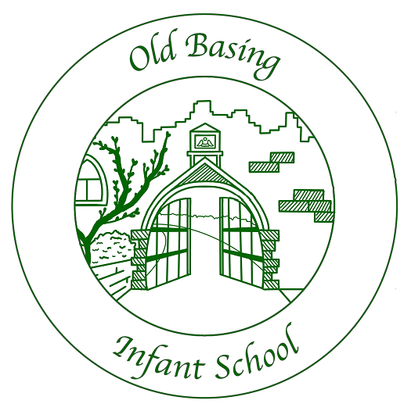

Job Description – Learning Support Assistant & Lunchtime Supervisory Assistant

Post Held: Learning Support Assistant /Lunchtime Supervisory Assistant

Name of post holder:

Responsible to: Year Group Leader and Class Teacher

Function:
- To support teachers in the provision of a positive learning environment
- To provide learning support for the children whilst encouraging them to grow towards independence
- To act as a good role model
- To give quality adult time

Main Duties:

- To promote the rights of the children in his/her care; having due regard to the UNCRC
- To work with children, individually or in a small group, in order to extend their learning and assist them in accessing the curriculum
- To deliver interventions relevant to children’s needs
- To take the whole class for some sessions when requested to do so
- To assist the teacher in carrying out assessments relating to core areas of learning
- To assist in monitoring and recording children's progress, through I.E.P.s where appropriate
- To provide regular feedback about individual children to the class teacher.
- To attend relevant staff meetings, in-service training days and undertake relevant training courses.
- To assist with the supervision of pupils during lessons and in the playground.
- To assist the class teacher in the general classroom environment; putting up and taking down displays, preparing equipment, generally tidying up the classroom (as much as possible with the children).
- To be part of the lunchtime team supporting children through the lunch hour both in the dining hall and on the playground.
- To undertake any reasonable duties requested by the Headteacher or Year Group Leader
- To accompany children on visits outside the school, under the direction of the class teacher.

Signed……………………………………………………..Date……………………

Old Basing Infant School
Person Specification – Learning Support Assistant

Qualifications
Essential | Desirable
- At least Level 2 Healthcare and Early Years Diploma or equivalent related to Early Education and Child Care or working in schools  - GCSE or equivalent in Maths & English | - T Level for Early Years or equivalent related to Early Education and Child Care or working in schools
Knowledge and Understanding
- Experience of working with young children  - Knowledge of the National Curriculum & EYFS Curriculum  - Knowledge of the UNCRC and committed to protecting and promoting children’s rights | - Experience of working with infant aged children  - Experience of supporting children through structured intervention programmes
Personal Attributes
- Be able to empathise with pupils and be sympathetic to their needs  - Be good communicators  - Have proven literacy & numeracy skills  - Act as a good role model for the pupils in their care  - Calm and patient, motivating the children with their learning through praise and encouragement  - Be firm but sensitive and have an effective approach towards pupil discipline, in accordance with the school’s Behaviour Management Policy  - Good organisational ability  - Able to apply knowledge and skills from training into practice  - Be able to work as a member of a team with the class teacher and the staff as a whole.  - Be willing to adapt and be flexible and positive in duties and approaches.  - Establish and maintain good relationships  - To act in a confidential manner  - To be a good listener  - Have enthusiasm and the ability to inspire and encourage children  - Able to work independently, with initiative  - Show a high level of commitment to the school  - Be prepared to undertake training to develop a greater understanding of the role, children's behaviour, children's learning and aspects of special educational needs. | - Have a good sense of humour  - Be prepared to ask for advice and support where necessary  - Be creative – able to offer new ideas, and suggestions

