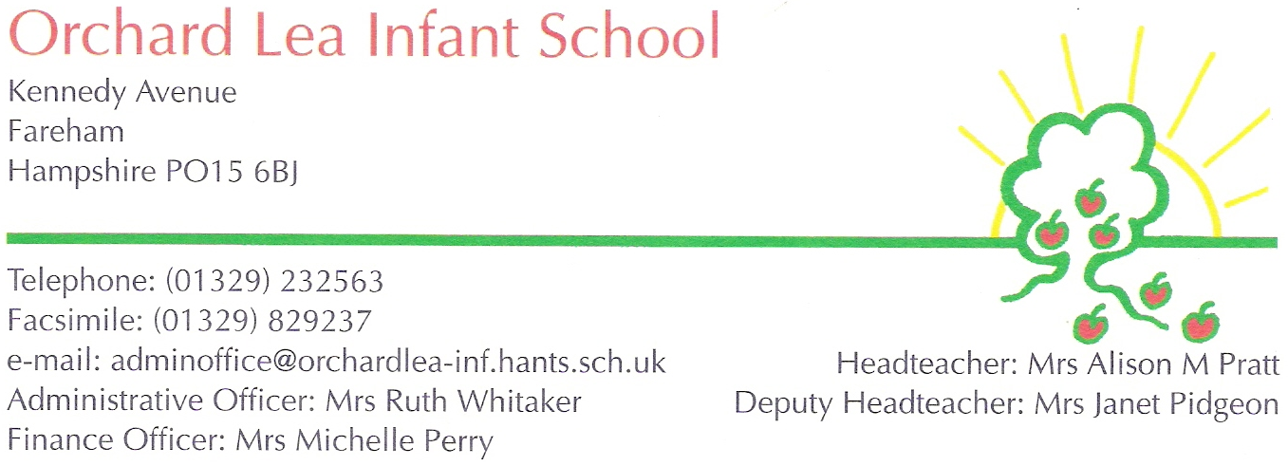  Orchard Lea Federation HLTA Job Specification.
Essential | Desirable
Qualifications: GCSE grade C or above for English and Maths, HLTA qualification. | Qualified Teacher Status, experience in a primary school or in a secondary school as a teacher.
Experience in teaching a whole class, delivering lessons and marking work in accordance with a marking policy | Knowledge of teaching phonics and Early years.
Experience in managing the behaviour of pupils and routines for a whole class. Experience in following a behaviour policy and maintaining discipline. | Knowledge and experience of running booster groups and catch up groups.
Experience in a primary school or at in at least either an infant or junior school and have knowledge of the primary curriculum. | To be able to contribute to the extra life of the school through a specialism or a club.
Ability to work flexibly and cover lessons as required, possibly at short notice. | Knowledge of primary school testing. For example, phonics screening, Y4 multiplication check and Y6 SATS.
To support with daily life in both schools- break duties and possibly lunch cover. To accompany pupils on trips and attend professional development meetings and training.
To act in accordance with the federation policies and know about how to keep self and pupils safe.
To be reliable and be able to build good relationships with pupils, staff and parents.

